nuBASIC
User's Guide

Copyright (C) 2014-2017 Antonino Calderone.
Permission is granted to copy, distribute and/or modify this document
under the terms of the GNU Free Documentation License, Version 1.3
or any later version published by the Free Software Foundation;
with no Invariant Sections, no Front-Cover Texts, and no Back-Cover Texts.
A copy of the license is included in the section entitled "GNU
Free Documentation License".

Index
1. About... 3
2. Command line interface 7
3. Integrated Development Environment (IDE) 20
4. The Language of nuBASIC 31
5. The Runtime Library 50
6. The Command Line Interface 62
7. Language Reference 66
8. How to download and install nuBASIC 85
9. nuBASIC samples 89
10. Licenses 95

About...

About this Guide
This guide provides an introduction to programming with nuBASIC.
Most of the content of this Guide is integrated into on-line documentation available at link http://www.nubasic.eu

To get the most out of this guide, you should be familiar with other programming languages.
Extensive examples are provided to help you quickly develop your own nuBASIC programs.

This guide divides information about nuBASIC into several chapters.
It begins describing the nuBASIC interface and follows with next chapters introducing you to nuBASIC.
Those chapters provides an overview of nuBASIC and should be read by anyone who intends to write nuBASIC programs.

About the author
nuBASIC and this Guide have been written by Antonino Calderone – antonino.calderone@gmail.com
(https://sites.google.com/site/eantcal/about)

About nuBASIC
nuBASIC program is an implementation of an interpreter of the programming language nuBASIC.
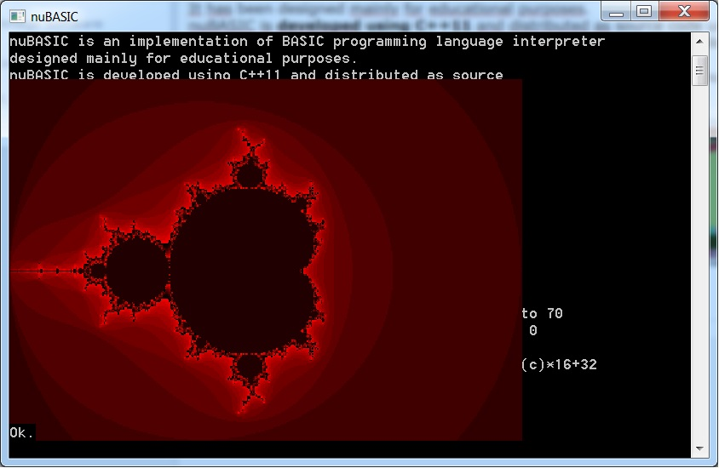Fig 1: Rosetta.bas output
As the name suggests, nuBASIC is a programming language from the BASIC family.
Anyone who has previously worked with other BASIC languages will quickly become accustomed to nuBASIC.
Large sections of the basic constructs of nuBASIC are compatible with other BASIC dialects.
The interpreter has been designed mainly for educational purposes both for C++ developers that can deal with a non-trivial example of modern C++ programming and for users, that may get hooked on programming.
nuBASIC interpreter is released as a compressed archive containing all source files.
They compile under several operating systems, including Linux, Microsoft Windows, and maybe others.
Binary packages are distributed for Microsoft Windows and several Linux distributions including Ubuntu and Fedora.

All nuBASIC releases can be downloaded from Sourceforge (https://sourceforge.net/projects/nuBASIC/)
nuBASIC homepage is http://www.nubasic.eu.

Why nuBASIC?

One good thing about nuBASIC is that it is very simple and is an excellent tool for teaching programming to a complete beginner.
It has also all features of a modern language, making it a good choice for any long term programming needs.
nuBASIC allows you to write both - classic programs which use line numbers, GoTo or GoSub control structures, and procedure oriented programs, based on procedural programming paradigm.

Example:
The following two implementations of Rosetta Code example (the Rosetta stone of Fractal geometry is the Mandelbrot set) run correctly on nuBasic interpreter:
5 Rem Rosetta.bas  10 For x0 = -2 To 2 Step .01  20 For y0 = -1.5 To 1.5 Step .01  30 x = 0  40 y = 0  50 iteration = 0  60 maxIteration = 223  70 xtemp = x*x-y*y+x0  80 y = 2*x*y+y0  90 x = xtemp  100 iteration = iteration + 1  110 If ((x*x+y*y<=4) And (iteration < maxIteration)) Then GoTo 70  120 If iteration <> maxIteration Then c = iteration Else c = 0  130 d%=150: dx%=300 : dy%=300  140 FillRect x0*d%+dx%,y0*d%+dy%,x0*d%+dx%+2,y0*d%+dy%+2,int(c)*16  150 Next y0  160 Next x0 | ' Rosetta.bas  For x0 = -2 To 2 Step .01  For y0 = -1.5 To 1.5 Step .01  x = 0  y = 0  iteration = 0  maxIteration = 223  While ((x*x+y*y<=4) And (iteration < maxIteration))  xtemp = x*x-y*y+x0  y = 2*x*y+y0  x = xtemp  iteration = iteration + 1  End While  If iteration <> maxIteration Then  c = iteration  Else  c = 0  End If  d%=150  dx%=300  dy%=300  FillRect x0*d%+dx%,y0*d%+dy%,x0*d%+dx%+2,y0*d%+dy%+2,int(c)*16  Next y0  Next x0

The nuBASIC programming language can be divided into two components:
- The language of nuBASIC: Defines the elementary linguistic constructs, for example, for variable declarations and loops.
- The built-in function library: provides standard functions for example, functions for modifying numbers and strings, and files.

Use of nuBASIC
nuBASIC can be used by any user without any additional programs. It has the components needed to create programs, including:
- The command line interpreter (CLI), which provides an inline-editor for creating and testing programs.
- The language interpreter, which is needed to run nuBASIC programs.
- Integrated Development Environment (IDE) for Windows.

Fig 2: IDE can be used to speed up developing of complex programs

Command line interface
The user interface of the nuBASIC interpreter is a command-line environment which, for example, has commands to Run, Load, Save, List the current program, or quit to the shell, Exit.
These commands cannot be used as program statements.
In addition to the list of commands, the CLI interprets nuBASIC instruction on-the-fly. This characteristic is especially useful for debugging purposes.
For example, you may inspect content of a variable by printing out its value, as follows:
Print variable

The complete list of CLI commands is the following
Command Syntax | Description
! shell_command | Executes shell command
? [print_parameters, ...] | Executes Print instruction
Apropos identifier | Searches a help content containing short descriptions of commands for keywords
Break [line [IF condition]] | Sets up a breakpoint at line specified. With “IF condition” breakpoint becomes conditional (it stops program execution only if condition becomes true).  If no parameters are provided, BREAK shows active breakpoints and related lines of code.
Build | Compiles program (useful for debugging purposes).
Clr | Clears all variables.
ClrBrk | Removes all breakpoints.
Cd <new directory> | Changes the current working directory.
Cont | Resumes program execution until your program completes, or stops on CTRL+C, or a breakpoint is hit.
Exec <program file> | Loads and runs a program file.
Exit | Exits the nuBASIC CLI.
Grep <pattern> | Lists lines containing a match to the given pattern.
Help [language_keyword] | Provides a description about keyword.  In case where keyword is not specified, shows the list of keywords, including commands, instructions functions and operators.
List [first][-last]  List [first-] | Lists all or part of a program.
Load filename | Loads a program file in memory.
New | Deletes the program currently in memory and clear all variables.
Pwd | Shows the current working directory.
Renum [increment(default=10)] | Renumbers program lines.
Run [line] | Executes the program currently in memory.
RmBrk line | Removes a breakpoint.
Save filename | Saves current program to file.
TrOn/TrOff | Enables/Disables program tracing.
StOn/StOff | Enables/Disables step-by-step execution mode
Ver | Prints out information about nuBASIC version.
Vars | Shows execution context information.
Meta | Shows meta information of program currently in memory.
Resume | This command is identical to CONT except for skipping interrupted line

Inline editor
The interpreter editor has a command line interface. You can use it to modify and run your programs, or if you prefer, you may use an external editor to create or modify them.

Using an external editor, program files can be saved in ASCII format and at a later time, load or executed using nuBASIC interpreter, for example by using the commands:

- nubasic -l “The program you created.BAS”
- nubasic -e “The program you created.BAS”

-l option executes the interpreter and loads the program;
-e executes the interpreter and runs the program.

The advanced external editor for Windows platform, is able to recognize the nuBASIC syntax will be discussed in next chapter.

Using the interpreter editor you can edit or debug nuBASIC program lines as you enter them, or after they have been saved in a program file.
You can make changes to the information in a line by positioning the cursor where the change is to be made, and by doing one of the following:
- Typing over the characters that are already there by pressing the INS key on the number pad.
- Deleting characters to the left of the cursor, using the BACKSPACE key.
- Deleting characters at the cursor position using the DEL key on the number pad.
- Inserting characters at the cursor position. This moves the characters following the cursor to the right making room for the new information.
- Adding to or truncating characters at the end of the program line.
- Recalling commands, using UP and DOWN keys
- Clearing current command line using ESC key
- Displaying command history using F7 key (Windows only)
- Clearing command history using Alt+F7 keys (Windows only).
- Searching for command beginning with <chars> by typing <chars> and pressing F8 key (Windows only)
- Selecting a command by number using F9 key (Windows only)

If you have changed a line, press Return and the modified line will be stored in the proper numerical sequence depending on number you have assigned to the line.
To modify an existing line, you may recall it using UP or DOWN keys and typing modification directly on the line text, then pressing ENTER you will store it.
If you don’t specify a line number, the statement will be executed immediately after pressing Return and will not be stored in the program.

Example:

For i%=1 to 10: Print "Count ";i%;" "; : Next

Count 1 Count 2 Count 3 Count 4 Count 5 Count 6 Count 7 Count 8 Count 9 Count 10

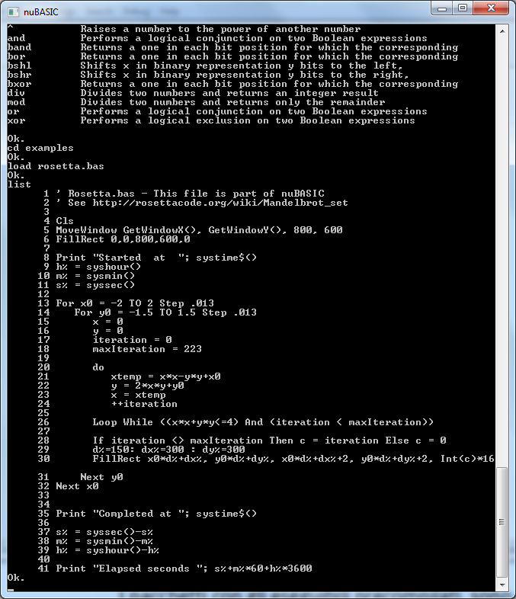Fig 3: nuBasic command line interface

Editing existing files
After you have entered your program and saved it, you may discover that you need to make some changes. To make these modifications, use the List statement to display the program lines that are affected:
- Reload the program using Load command.
- Type the List command.
- Type the line number, or range of numbers, to be edited.

Example:

Load “parabola.bas”

Ok.
list -100
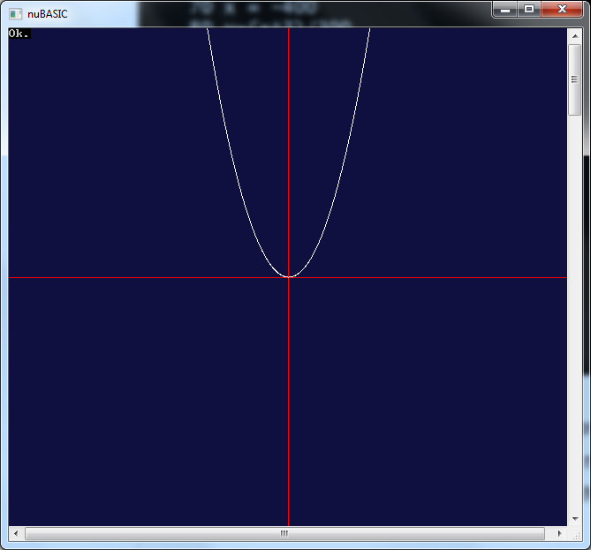Fig 4: Output of example parabola.bas modified as shown in the example
10 Cls
20 Line 400,0, 400, 800, &hff
30 Line 0,300, 800, 300, &hff
40 Line 0,0,0,1, &hff
50 old_x = 0
60 old_y = 0
70 x = -400
80 y=(x^3)/300
90 If y>600 Then End
100 y%=300-y

Ok.
80 y=x*x/30
90 If y>600000 Then End

list 80-100
80 y=x*x/30
90 If y>600000 Then End
100 y%=300-y
Ok.

run

The proper way to insert lines of code between two existing lines is to use line number within the interval of the two line numbers.

Renum command may be used to renumber the program lines after those modifications.

Despite nuBasic interpreter editor uses line numbers, you don't need them in your programs.
The interpreter does not need line numbers to handle program flow if you use labels with GoTo/GoSub statements.
If your program does not refer line numbers (but just labels), nuBASIC strips line numbers during file saving and reinsert them automatically when program is loaded at later time.
In this case, line numbers are provided only for editing and debugging purpose.

In memory |  | In the program file
10 Cls  20 repeat:  30 Print “Hello World”  40 GoTo repeat | Saved as  -> | Cls  repeat:  Print “Hello World”  GoTo repeat

The following program is considered 'old-style' because of using of numbered reference in a GoTo statement (GoTo statement at 40 points to line 20).
This old style program maintains line numbers when you save it in a file:

In memory |  | In the program file
10 Cls  20 Rem repeat  30 Print “Hello World”  40 GoTo 20 | Saved as  -> | 10 Cls  20 Rem repeat  30 Print “Hello World”  40 GoTo 20

Using command Meta you may verify if a program has explicit line number references.
Line number reference with GoTo or GoSub statements is deprecated.

Executing nuBASIC program from Linux Shell
Once nuBASIC is installed in your system, you are able to run .bas program directly from the o/s shell, just executing them.
In order to allow Linux to recognize nuBASIC interpreter you have to insert as first line of your source code this special string:
#!<path_where_nu_basic_is_installed>/nubasic

For example,
#!/usr/local/bin/nubasic

A bash script (make_bas_exec.sh) is provided to make easy this job, defined as follows:
file="$1"

if [ -z $file ]
then
echo "Usage: $0 filename"
exit 0
fi

if [ -f "$file" ]
then
echo "$file found."
else
echo "$file not found."
exit 1
fi

# Remove Ctrl+M
dos2unix $1 2> /dev/null

cp -a $1 $1.bak && echo "#!`which nubasic`" > $1 && grep -v "^#!" $1.bak >> $1 && chmod +x $1 || error=1

if [ -z $err ]
then
echo "Operation completed"
exit 0
else
echo "Error making $1 executable"
exit $error
fi

Executing nuBASIC program from Windows
Once nuBASIC is installed in your system, Windows is able to recognize .bas files and associate them with nuBASIC interpreter.
In order to execute a nuBASIC program just click on the filename.bas icon (using explorer) or from console terminal, just type program name, with complete path if it is not in the current directory, (for example rosetta.bas) and it will be execute.

Built-in usage help
The CLI also contains an inline help system to provide descriptions and syntax for each command via the Help and Apropos commands. Giving no argument to Help, it lists all operators, keywords, built-in functions, available in nuBASIC divided into four categories: commands, instructions, functions and operators.
Giving as argument a keyword, Help displays the help text for that keyword.
For example, the command help open prints out a text describing the Open statement, as follows:

help open

Open filename [For mode][Access access] AS [#]file-number

Establishes input/output (I/O) to a file.

'filename' is the name of the file to be opened
'mode' determines the initial positioning within the file,
and the action to be taken if the file does not exist.
Input - Position to the beginning of the file.
A "File not found" error is given if the file does not exist.
Output - Position to the beginning of the file.
If the file does not exist, one is created.
Append - Position to the end of the file.
If the file does not exist, one is created.
Random - Specifies random input or output mode.

'access' can be one of the following :
Read
Write
Read Write

See also FOpen, Close, Input#, Print#, Write#, Seek, FTell, FError, Errno, Errno$

Apropos is command to search help content. It is used to search all help data for the string specified. This is often useful if one knows the action that is desired, but does not remember the exact command.
The following example demonstrates the output of the Apropos command:
apropos file

exec Loads and runs a program file
load Loads a program file in memory
save Saves current program to file
close Terminates input/output to a file.
flush Shall cause any unwritten data for that file number to be written to ...
fopen Establishes input/output (I/O) to a file.
input# Inputs data from file that will be placed into a list of variables.
open Establishes input/output (I/O) to a file.
print# Prints list of expressions to file (0-standard output)
read Reads data from file that will be placed into a variable.
seek Moves the file pointer to a specified location
write# Prints list of expressions to file (0-standard output)
eof Checks the end-of-file indicator.
ferror Tests for an error on a file.
fsize Returns the current size in bytes of the file
ftell Returns the current value of the position indicator of the file

Program File Commands
The following are the commands and statements most frequently used with program files.
- Save “filename”
Writes to storage unit the program currently residing in memory.
- Load “filename”
Loads the program from a storage unit into memory. LOAD deletes the current contents of memory before loading the program.
- Run
Runs program present in memory.
- ! command
Invokes the command processor of the shell to execute a command.

Example:

Ok.
! "ls examples/*"
examples/bg.bmp examples/fact.bas examples/parabola.bas
examples/bitmap.bas examples/graph.bas examples/ray.bas
examples/breakout.bas examples/guess.bas examples/readfile.bas
examples/breakout2.bas examples/line.bas examples/recursive.bas
examples/breakout3.bas examples/minehunter.bas examples/rosetta.bas
examples/calc.bas examples/nutris.bas examples/tictactoe.bas
examples/cartoon.bas examples/nutris3D.bas examples/walk.bmp
examples/code.bas examples/nutrisbg.bmp

Debugging
nuBASIC has debugging facilities to help you catch bugs in your programs.

Breakpoints
Breakpoints are used to interrupt a running program immediately before the execution of a programmer-specified line.
You can place breakpoints at lines in your code and run the program until one of the specified breakpoints is hit. Breakpoints can be specified to be hit as soon as the line of code is about to be executed.

To insert a breakpoint use the Break command with a line number.
Cont command continues program execution after a breakpoint.

Breakpoints can be easily removed when you no longer need them.
To remove a breakpoint use the RmBrk command specifying the line number which breakpoint is set.

Using command ClrBrk you can remove all breakpoints.
Breakpoints are also automatically removed if New, Exec or Load commands are issued.

Example:
1 For i = 1 To 5  2 Print i  3 Next  break 2  Ok.  run  Execution stopped at breakpoint, line 2.  Type 'cont' to continue  cont  1.000000  Ok.  list  1 For i = 1 To 5  * 2 Print i  3 Next | Insert an unconditional breakpoint at line 2  Program stops at line 2  Typing Cont the executions continues from line 2  Program stops at line 2 (again)  List command shows lines with breakpoints with star (*) character on the left.

Conditional breakpoints
A conditional expression can be applied to a line breakpoint such that the breakpoint suspends execution of a program when the result of the expression is true.
A conditional expression can contain arbitrary nuBASIC Boolean expression code.

Example:
1 For i = 1 To 5  2 Print i  3 Next  break 2 if i>4  list  1 For i = 1 To 5  * 2 Print i  Breakpoint at 2 if i>4  3 Next  Ok.  run  1.000000  2.000000  3.000000  4.000000  Execution stopped at breakpoint, line 2.  Type 'cont' to continue  Ok. | Insert an conditional breakpoint at line 2  (program stops only when i>4)  List shows conditional breakpoints  Run program until it stops at line 2 when i>4

Inspecting program constructs and variables
You may evaluate expressions, execute statements, print variable values (Print, ?), and so forth.
Interpreter allows you to enter expressions to be evaluated or executed directly.
Besides that, you can see execution context using Vars command.
For example you may stop program execution (using CTRL+C keys combination or setting up a breakpoint) and see the program context using the Vars command.

An example of Vars command output is shown below:

184 if level%<=12 then mdelay 60-level%*5  Go-To line : next  End request pending: N  Return request pending: N  Skip-till-NEXT request pending: N  Jump request pending: N  Variables[<GLOBAL>]:  a: FLOAT(bytes:4): 0.513993  a$: STRNG(bytes:1): "v"  a%: INTGR(bytes:4): 1  akey$: STRNG(bytes:1): " | - Line of code of last statement executed  - Go-To line: shows the line where program continues execution  - Show the request of program termination if an End statement executed  - T (true) if an Exit For statement previously executed, F (false) otherwise  - T (true) if a jump-statement (such as GoTo or others) executed  - Show variable context (<GLOBAL> or “procedure-name-scoped”).  The context consists in the list of variables, sizes in bytes and corresponding dynamic values.

You may also inspect the meta-data information result of program-build using Meta command.
An example of Meta command output is shown below:

Explicit line number reference detected: N  Last compiled line : 269  Last compiled stmt : 0  Labels:  drawplayer: 158  drawwall: 165  handleplayer: 147  initwallmap: 198  processcollision: 212  processplayerballcollision: 240  WHILE loop metadata:  exit flag : N begin pc: 43 end pc: 144  exit flag : N begin pc: 53 end pc: 142  exit flag : N begin pc: 80 end pc: 138  Exit point: 113 Block PC:80  Exit point: 130 Block PC:80  Exit point: 140 Block PC:53  IF statement metadata:  exit flag : Y begin pc: 91 end pc: 96 else pc: 94  exit flag : Y begin pc: 98 end pc: 114 else pc: 0  exit flag : N begin pc: 106 end pc: 110 else pc: 0  exit flag : Y begin pc: 116 end pc: 131 else pc: 0  exit flag : N begin pc: 172 end pc: 176 else pc: 174  exit flag : N begin pc: 217 end pc: 223 else pc: 0  exit flag : N begin pc: 218 end pc: 222 else pc: 0  exit flag : Y begin pc: 225 end pc: 234 else pc: 0  exit flag : N begin pc: 229 end pc: 232 else pc: 0  exit flag : Y begin pc: 241 end pc: 245 else pc: 0  exit flag : Y begin pc: 262 end pc: 264 else pc: 0  Exit point: 94 Block PC:91  Exit point: 174 Block PC:172 | - If Y (Yes) it means program contains explicit reference to line numbers  - Shows the number of last line compiled (to build showing meta-data)  - Shows the index of last statement compiled (to build showing meta-data)  - Lists the program labels with corresponding numbers  - Shows While-Loop information (exit flag can be Y if an Exit While statement is dynamically encountered). Similar information data is provided for other control-loop statements.  - Exit point represents the Exit While statements and corresponding While block of code it refers.  - Shows If-Then-Else information.  Here the “exit flag” refers to IF-statement condition. It varies dynamically during program execution.

Tracing
Tracing is used to provide run-time (per-running-statement) information about a program's execution. Those information are the same shown by typing Vars command, and may vary dynamically during program execution.
To enable tracing use the TrOn command. To disable tracing use the TrOff command.

Example of tracing output:
10 Input "Insert x:"; x
20 Print "Square of x is "; x*x

Ok.

tron

run

IDNT[input] BLNK[ ] STRL[Insert x:] OPER[;] BLNK[ ] IDNT[x]
IDNT[print] BLNK[ ] STRL[Square of x is ] OPER[;] BLNK[ ] IDNT[x] OPER[*] IDNT[x]

Insert x:?3
10 input "Insert x:"; x
Go-To line : next
End request pending: N
Return request pending: N
Skip-till-NEXT request pending: N
Jump request pending: N
Variables[<GLOBAL>]:
x: FLOAT(bytes:4): 3

Square of x is 9.000000

20 print "Square of x is "; x*x
Go-To line : next
End request pending: N
Return request pending: N
Skip-till-NEXT request pending: N
Jump request pending: N
Variables[<GLOBAL>]:
x: FLOAT(bytes:4): 3

Step-by-step execution
You may have enabled step-by-step execution mode by typing the command StOn (and disable it by using the command StOff).
When step-by-step execution mode is enabled, execution would proceed by using the command Cont.
This execution mode might be to determine if the correct program flow is being followed in the program during the execution or to see if variables are set to their correct values after a single step has completed.

Integrated Development Environment (IDE)
The IDE provides an advanced syntax highlighting editor, an interpreter and a debugger into a unique application for Windows and Linux (GTK+2).
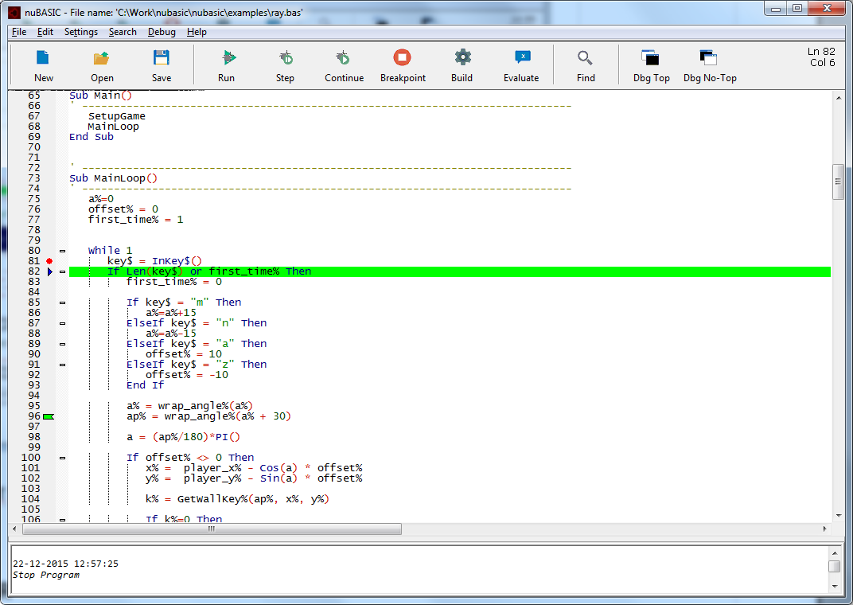
Fig 5: a screenshot of nubasic ide for windows

Syntax Highlighting Editor
The syntax highlighting editor for nuBASIC is available as an alternative to the screen editor integrated with the CLI interpreter discussed in the previous chapter. It provides specialized features for editing nuBASIC code.
It is particularly useful to write non-trivial programs.

Main editor features
- Syntax highlighting: which is the ability to recognize nuBASIC keywords and display them in different colors.
- Folding: you can hide or display lines of code with its indent levels.
- Auto completion is a time-saving feature which changes a short abbreviation into a keyword string.
- Bookmarks: you can bookmark a particular line and later return to it quickly.
- Search and Replacement: for searching for occurrences of a string and replacing them with another.
- Online help: you can launch the online help system by selecting a keyword and pressing F1
- Integrated debug support: lets you place breakpoints in your source code, add field watches, step through your code, run into procedures, take snapshots and monitor execution as it occurs.

Keyboard commands
Editor keyboard commands mostly follow common Windows conventions.
All movement keys (arrows, page up/down, home and end) allow to extend or reduce a stream selection when holding the Shift key, and a rectangular selection when holding the Shift and Alt keys.
Some keys may not be available with some national keyboards or because they are taken by the system.
Keyboard equivalents of menu commands are listed in the menus.
Some less common commands with no menu equivalent are:
Indent block. | Tab
Dedent block. | Shift+Tab
Delete to start of word. | Ctrl+BackSpace
Delete to end of word. | Ctrl+Delete
Delete to start of line. | Ctrl+Shift+BackSpace
Delete to end of line. | Ctrl+Shift+Delete
Go to start of document. | Ctrl+Home
Extend selection to start of document. | Ctrl+Shift+Home
Go to start of display line. | Alt+Home
Go to end of document. | Ctrl+End
Extend selection to end of document. | Ctrl+Shift+End
Go to end of display line. | Alt+End
Scroll up. | Up
Scroll down. | Down
Line cut. | Ctrl+L
Line delete. | Ctrl+Shift+L
Selection duplicate. | Ctrl+D
Previous paragraph. Shift extends selection. | Ctrl+[
Next paragraph. Shift extends selection. | Ctrl+]
Previous word. Shift extends selection. | Ctrl+Left
Next word. Shift extends selection. | Ctrl+Right
Previous word part. Shift extends selection | Ctrl+/
Next word part. Shift extends selection. | Ctrl+\
Rectangular block selection. | Alt+Shift+Movement
Extend rectangular selection to start of line. | Alt+Shift+Home
Extend rectangular selection to end of line. | Alt+Shift+End

Folding
Program source code files can be thought of as containing a hierarchy of sections, which themselves might contain sub-sections.
The folding feature lets you selectively hide and show these sections, replacing hidden ones with a single line that serves as an “overview” of that section.
Fold points are based upon indentation.
Fig 6: The picture shows an example of folding use
The fold point markers (in the fold margin) can be clicked to expand and contract folds. Normal clicking does not alter the fold state of child fold points; naturally the children are hidden when the parent fold is contracted, but when the parent is expanded again, each child is still folded or not, as before.
Ctrl+Click on a fold point toggles it and performs the same operation on all children.
Shift+Click on a fold point does not toggle that fold, it expands all the child folds.
Ctrl+Shift+Click in the fold margin expands or contracts all the top level folds. "Toggle all folds" in the View menu does the same; it toggles only top-level folds.
Tip: To open a large code block with all its children folded, fold it with Ctrl+Click, then open it with a normal click. Then on opening a child fold, you will see that the grandchild folds are still closed; if you want those 'grandchild' folds open, Shift+Click the child fold.

Find and Replace
The Find command enables you to locate specific text in your document.
To find specific characters or words click the Search menu, and then click "Find..." or press Ctrl+F.
Find dialog box will enable you to search in the text.
In the Find what box, you have to type the characters or words you want to find.
If you have previously selected editing text, this appears automatically into Find want box.
Under Direction, click Up to search from the current cursor position to the top of the document, or click Down to search from the cursor position to the bottom of the document.
Fig 7: Find dialog box
- Find what: Enter the string to match.
- Match whole word only: Select to find text strings that match the Find What string and are preceded and followed by a space, tab, or punctuation character, or at the start or end of a line.
- Match case: Select to find only the text strings that exactly match the case of the characters in the Find what string. Otherwise, the command finds strings with either uppercase or lowercase characters that match the characters in the Find What string.
- Find Next button: click to find the text

To replace specific characters or words click the Search menu, and then click "Find and Replace..." or press Ctrl+R
Fig 8: Replace dialog box
- Replace with box: Enter the replacement text.
- Find Next button: click to find the text
- Replace button: click to replace text matching with Find what text
- Replace all: click to replace all instances of the text

Bookmarks for file navigation
A marker is a pointer to a specific line of the text.
Lines which contain markers are indicated with a circle on the left.

Fig 9: The picture shows an example of markers
Bookmarks command are listed on the menu Search.

Fig 10: Search MENU
Menu Command | Description | Shortcut key
“Add/Remove maker” | Adds a marker to the current line. If a marker is already set on the current line, the marker is removed instead. | CTRL+F7 (Windows)
“Find next marker” | Goes to next marker in the text | CTRL+F8 (Windows)
“Find previous marker” | Goes to previous marker in the text | CTRL+F9 (Windows)
“Remove all markers” | Removes all markers set in the current text

Auto-completion
Auto-completion displays a list box showing likely identifiers based upon your typing.
You may choose the currently selected item by pressing the tab character.
You can activate auto-completion by pressing F12.
Fig 11: Keyword auto-completion

Toolbar
The toolbar is an element on which buttons related to common commands are placed.

The toolbar shown in Fig.12 contains commands relating file, debugging and search operations.
Fig 12: Toolbar
Toolbar Item | Menu Item | Shortcut
New | File → New | Ctrl+N
Open | File → Open... | Ctrl+O
Save | File → Save | Ctrl+S
Debug | Debug → Start Debugging | F5
Breakpoint | Debug →Toggle Breakpoint | F9
Build | Debug → Build Program | Ctrl+B
Evaluate | Debug → Evaluate Selection | F11
Step | Debug → Step | F10
Cont | Debug → Continue Debugging | F8
Find | Search → Find... | Ctrl+F
Dbg Top | Debug → Debug Window Topmost
Dbg No-Top | Debug → Debug Window Not-Topmost

The toolbar also displays information that pertains to editing like the line number or column number of the cursor location, or indication if program has pending unsaved changes.

Launching Context-sensitive help and On-line Help from editor
You can launch the context-sensitive help system by selecting a keyword and pressing F1.

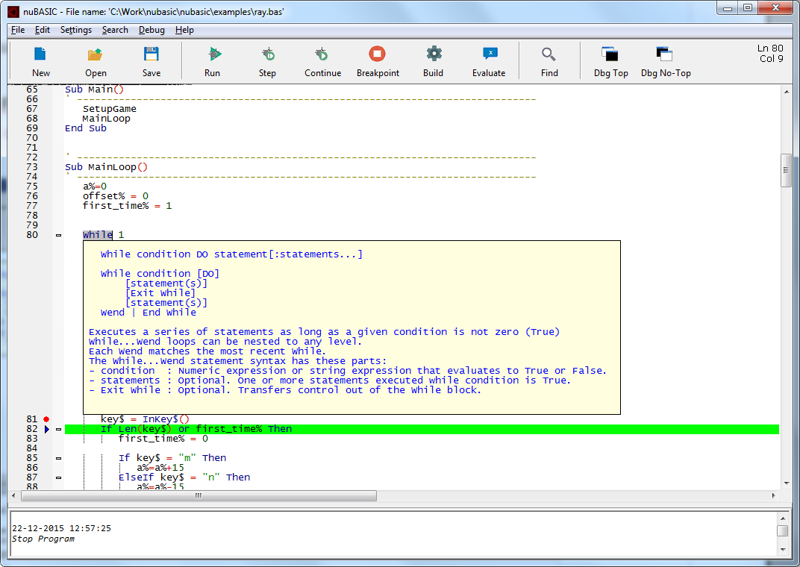Fig 13: context-sensitive help

You can launch the on-line help system by selecting a keyword and pressing Ctrl+F1.
The online help opens on internet browser and the related help topic is searched and displayed.

Fig 14: ON-LINE HELP

Integrated Debugger
The integrated debugger, together with advanced text editor with syntax highlighting, auto-completion, and error checking, provides a development tool that makes solving non-trivial coding issues easier and supports more accurate and efficient code development.

Debug Menu
You can easily access to the debugging commands from a drop down menu.
Debugging commands allow you to follow your code line by line, with debugging actions by using step-by-step execution, breakpoints. You can also inspect complex nuBASIC expressions dynamically.

Fig 15: Debugging Menu

Build Program | CTRL+B | nuBASIC interpreter builds the program meta data used for subsequent executions.  This command is performed automatically first time you start application and if you have modified it before further executions.
Start Debugging | F5 | When you choose Start Debugging on the Debug menu, nuBASIC IDE launches the program with the debugger attached. Execution continues until a breakpoint is reached, you manually suspend execution via CTRL+C, an exception occurs, or the program ends.
Continue Debugging | F8 | You can resume execution of the program by choosing an execution command like Continue
Step | F10 | One of the most common debugging procedures is stepping.  Stepping is executing code one line at a time.  When you have halted execution, such as running the debugger to a breakpoint, you can use three Debug menu commands to step through code.  If the line contains a sub call, Step executes only the call itself, then halts at the first line of code inside the procedure. Otherwise, Step executes the next statement.
 |  | If the line contains a function call, Step executes the called function, then halts at the first line of code inside the calling function.
Evaluate selection (Data-Tips) | F11 | Data-Tips are one of the most convenient tools for viewing information about the variables and expressions in your program during debugging.  When the debugger is in break mode, you can view the value of a variable within the current scope by selecting the variable or the expression in a source window and activating the Data-Tip by using this command or pressing F11.
Start without Debugging | CTRL+F5 | It starts the program without the integrated debugger attached.  If you press CTRL+C when program running, you can stop the interpreter execution and a CLI prompt is show. See CLI section of this Guide for more information about it.
Toggle Breakpoint | F9 | Enable or disable a breakpoint.  When the breakpoint has been set, it is represented by an icon in the gray bar to the left of the statement.
Delete all Breakpoints |  | Remove any breakpoint previously set
Go to Program Counter |  | Show the next line that will be execute in case of resuming program execution
Go to Procedure |  | Move the cursor to the entry-point of the procedure selected from sub-menu shown when this item is selected. The sub-menu shows all the functions and procedures of the program. This sub-menu is generating dynamically whenever code is rebuilt
Debug Window topmost |  | Places debug window above all non-topmost windows. The window maintains its topmost position even when it is deactivated.
Debug Window no-topmost |  | Places debug window above all non-topmost windows (that is, behind all topmost windows).

The Language of nuBASIC
nuBASIC belongs to the family of BASIC languages. Many parts of nuBASIC are identical to other Basic dialects. Anyone who has already worked with these languages can quickly become accustomed to nuBASIC.
Programmers of other languages should also find it easy to familiarize themselves with nuBASIC.
This chapter provides an overview of the key elements and constructs of the nuBASIC language.

Program lines and statements
A nuBASIC program will normally consist of a series of statements.
These statements could comprise assignment that define new variables, conditional statements and flow control statements.
nuBASIC supports old-style programs where all the statements begin with a line number or new one where line number is not allowed. The first format is supported but deprecated.
nuBASIC language is compatible with modern structured programming theory by discarding the line numbers and adding the control structures and subroutine definitions needed by structured programming.
Line numbers | Labels
10 Cls  20 Rem repeat  30 Print “Hello World”  40 GoTo 20 | Cls  repeat: ' <- label  Print “Hello World”  GoTo repeat

The BASIC interpreter's line-oriented execution produces one of the key differences between BASIC and other programming languages. Whereas the position of hard line breaks in the source code of Java or C++ programs is irrelevant, each line in a BASIC program forms a self-contained unit.
Function calls, mathematical expressions, and other linguistic elements, such as function and loop headers, must be completed on the same line that they begin on.
To linking individual lines you can use colons to divide one line into several sections so that there is enough space for several expressions.
For example, the assignments
a% = 1
a% = a% + 1
can be written as follows:
a% = 1: a% = a% +1

Labels
Lines of code preceded by an identifying string or integer are said to be labeled.
Statement labels are used to mark a line of code to identify it for use with statements such as GoTo or GoSub.
Labels may be valid identifier, such as those that identify programming elements.
A label must appear at the beginning of a line of source code and must be followed by a colon.
Labels have their own declaration space and do not interfere with other identifiers.
Cls
repeat: ' <- label
Print “Hello World Forever”
GoTo repeat

Comments
In addition to the program code to be executed, a nuBASIC program can also contain comments that explain the individual parts of the program and provide important information that can be helpful at a later point.
nuBASIC provides two methods for inserting comments in the program code:
- All characters that follow an apostrophe are treated as comments:
Dim A(10) ' This is a comment for array A
The comment symbol (') tells the nuBASIC interpreter to ignore the text following it, or the comment. Comments are brief explanatory notes added to code for the benefit of those reading it.
- The keyword REM, followed by the comment:
Rem This comment is introduced by the keyword REM

A comment includes all characters up to the end of the line.

Identifiers
A nuBASIC program can contain many identifiers, which are names for variables, functions and so on.
- Identifiers can only contain letters, numbers, and underscores (_).
- The first character of an identifier must be a letter or an underscore.
- Identifiers cannot contain special characters.
- No distinction is made between uppercase and lowercase characters.

Literal constants
Constants are static values the nuBASIC Interpreter uses during execution of your program.
There are two types of constants: string and numeric.
A string constant is a sequence of alphanumeric characters enclosed in double quotation marks.
The following are sample string constants:
"Hello World", "nuBASIC is written in C++11",
"Escape character \" is used to insert double quotation mark within a string"
A string consists of a sequence of consecutive individual characters. The interpreter saves the strings internally as a sequence of numbers where each number represents one specific character.
Character sets match characters in a string with a corresponding code (numbers and characters) in a table that describes how the computer is to display the string.
nuBASIC uses ASCII coding. The ASCII character set is a set of codes that represent numbers, characters, and special symbols by one byte. The 0 to 127 ASCII codes correspond to the alphabet and to common symbols (such as periods, parentheses, and commas), as well as some special screen and printer control codes. The ASCII character set is commonly used as a standard format for transferring text data between computers.

Numeric constants can be positive or negative, integer (decimal or hexadecimal) or else floating point.
Constant type | Example | Range
Integer number (32 bit) | 255, -128, &hFF | -2147483648 to 2147483647 (decimal)  &H80000000 to &H7FFFFFF (hexadecimal)
Integer number (64 bit) | 1000000000 | &H8000000000000000 to &H7FFFFFFFFFFFFF (hexadecimal)
Floating pointer  (single precision, 32 bit) | 12.3E-10 | ca. +/- 1.2 ⋅ 10⁻³⁸ to 3.4 ⋅ 10³⁸
Floating-point  (double precision, 64 bit) | 2.2 E-308 | c.a. +/- 2.2 10⁻³⁰⁸ 1.8 ⋅ 10³⁰⁸

Variables
A variable is a storage location paired with an associated symbolic name called identifier.
Variables allow you to store and change information.
Below is an example how to use variables.
AString$ = "Hello World"
Anumber% = 10

Print AString$
Print Anumber%

A variable identifier consists in a valid identifier (as described before) optionally followed by the
- Implicit “as String” declaration using character $
- Implicit “as Integer” declaration using character %,
- Implicit “as ByteVect” (byte-array-type) declaration character @,
- Implicit “as Double” (double-precision) floating-point character !,
- Implicit “as Boolean” declaration character #,
- Implicit “as Long64” 64 bit integer-type declaration character &
In case where type declaration character is not specified, floating point type will be assumed.
nuBASIC enables both the creation of a variable through simple assignment without an explicit declaration statement and the declaration of a variable specifying its name and characteristics using Dim statement .
In other words, a variable exists from the moment that you assign it a value in your code or declare it by using Dim.
A=-123.5 : Rem Floating-point
A!=1E50 : Rem Double floating-point
A%=&HFF0000 : Rem Integer 32 bit
A$=”This is a string” : Rem String
A#=false : Rem Boolean
Dim s as String : Rem s is a String variable

Array Variables
An array is a group of values referenced by the same variable name.
Each element in an array is referenced by an array variable that is a subscripted integer or an integer expression.
The subscript is enclosed within parentheses.

Dim A(10) : Rem A is an array of ten elements
A(0)=1.0 : Rem A(0) is first element, A(9) the last one

nuBASIC supports single dimension arrays.
An array must be declared explicitly using construct Dim.
In an array declaration the array name is followed by parentheses which contain the specifications for the number of elements.
The first element of an array has index 0 and the last one has index equal to length of the array decreased by one.
The byte-array represents raw type which can be used for containing any data content type.
A data buffer can be declared using the statement Dim or ReDim.
Dim BUF@(1024) : Rem A is an array of bytes
Print SizeOf(BUF@) : Rem Prints out 1024

You can copy an array object content into another one, if their size and type matches, by using a simple assignment operation, as the following examples shows, where B1@ is copied into B2@:

Dim B1@(4), B2@(4)
Rem …
B2@ = B1@

Structures
A structure in nuBASIC is a composite data type consisting of a number elements of other types.
A nuBASIC structure is a value type and the instances of a structure are created in stack.
The keyword struct can be used to declare a structure.
The general form of a structure declaration in nuBASIC is as follows.

Struct <struct_name>
field1 [as FieldType1]
field2 [as FieldType2]
...
fieldn [as FieldTypeN]
End Struct

Example:
Struct MyStruct
x As Integer
y As String
End Struct

The objects of a struct can be created by using the Dim statement as follows.

Dim strucvar as MyStruct

The individual members of a struct can be accessed by using the dot (.) operator as showing below.

strucvar.x = 10
strucvar.y = 20

You can use structures in conjunction with arrays. The interactions use the same syntax as these elements use individually.

Example
Struct myStruct
x(10) as String
y as Integer
end Struct

Dim s1 as myStruct
Dim s2(2) as myStrct

s1.x(0) = “Hello”
s1.y = 10

s2(0).x(0) = “Hello”
s2(0).x(1) = “World”

s2(1).x(0) = “One”
s2(1).x(1) = “Two”
s2(1).y = 3

Operators
nuBASIC understands common mathematical, logical, and comparison operators.
Mathematical operators can be applied to all numbers types, whereas the + operator can also be used to link strings.

+ | Addition of numbers and date values, linking of strings
- | Subtraction of numbers
++ | Prefix Increment Operator
-- | Prefix Decrement Operator
* | Multiplication of numbers
/ | Division of numbers
\  Div | Division of numbers with a whole number result (rounded)
^ | Raising the power of numbers
Mod | Modulus operation (calculation of the remainder of a division)

Logical operators, OR, AND, XOR, allow you to link elements according to the rules of Boolean algebra.
Bitwise operators treat their operands as a set of 32 bits (zeros and ones), rather than as decimal.

Operator | Usage | Description
Bitwise AND | a bAnd b | Returns a one in each bit position for which the corresponding bits of both operands are ones.
Bitwise OR | a bOr b | Returns a one in each bit position for which the corresponding bits of either or both operands are ones.
Bitwise XOR | a bXor b | Returns a one in each bit position for which the corresponding bits of either but not both operands are ones.
Bitwise NOT | bNot(a) | Inverts the bits of its operand.
Left shift | a bShl b | Shifts a in binary representation b bits to the left, shifting in zeros from the right.
Sign-propagating  right shift | a bShr b | Shifts a in binary representation b bits to the right, discarding bits shifted off.
Comparison operators can be applied to all elementary variable types, including strings.

= | Equality
<> | Inequality
< | Less than check
> | Greater than check
<= | Less than or equal to check
>= | Greater than or equal to check

Operator precedence
Operators are evaluated in the following order of precedence:
- Unary identity and negation (+, –).
- Unary prefix increment and decrement operators (++, --)
- Exponentiation (^), Multiplication and floating-point division (*, /), Integer division (\, Div), Modulus arithmetic (Mod).
- Addition and subtraction (+, –).
- Comparison operators (=, <>, <, <=, >, >=).
- Logical Conjunction (And), Inclusive disjunction (Or), Exclusive disjunction (Xor), bit-wise operators

When operators of equal precedence occur together in an expression, for example multiplication and division, each operation is evaluated as it occurs from left to right. Parentheses can be used to override the order of precedence and to force some parts of an expression to be evaluated before others. Operations within parentheses are always performed before those outside. Within parentheses, however, operator precedence is maintained.
The = operator, if part of an expression is only the equality comparison operator, not the assignment operator.
The general syntax of an assignment statement is variable=expression.
Unary operator “not” is not implement, while the function Not(expression) is provided, so the following statement is not allowed
a = Not b : ' Syntax error

The following one is allowed
a = Not(b) : ' OK, this works

Expression
An expression is any valid unit of code that resolves to a value.
An expression may be simply a string or numeric constant, a variable, or it may combine constants and variables with operators and functions to produce a single value.

Boolean expression
Boolean expressions evaluate to numeric, and numeric can be used inside of Boolean expressions.
The value 0 is false, while any other value is true.

Program flow control
Control structures allow you to regulate the flow of your program's execution. Using control structures, you can write BASIC code that makes decisions or that repeats actions.

If...Then...Elif...Else…End if
The If statement conditionally executes a group of statements, depending on the value of an expression.

Syntax:
If expression Then statement(s) [Else statement(s)]

If expression Then
statement(s)
[ Elif expression Then
statement(s)
Elif expression Then
statement(s)
...

Else
statement(s) ]
End If

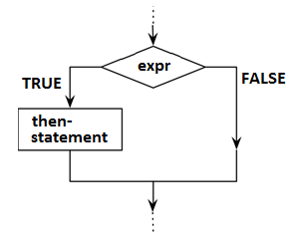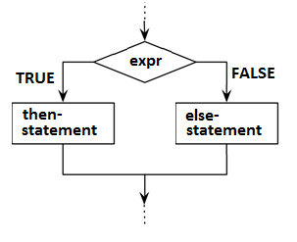

If the result of expression is nonzero (logical true), the Then statement is executed.
If the result of expression is zero (false), the Then statement is ignored and the Else statement, if present, is executed.
Elif, as its name suggests, is a combination of If and Else. Like Else, it extends an If statement to execute a different statement in case the original If expression evaluates to False. However, unlike Else, it will execute that alternative expression only if the Elif conditional expression evaluates to True.

Example 1:

If N%<20 And N%>10 Then Print "OK": GoTo skip_error
Print "N% IS OUT OF RANGE"
skip_error:
Rem --- N% is in the range (10..20)

Example 2:

If x>0 Then Print "Positive" Else Print "Negative"

Example 3:

' If A > 10, execute the three colon-separated statements in the order
' that they appear
If A > 10 Then A = A + 1 : B = B + A : C = C + B

Example 4:

' If A > 10, execute the three statements in the order
' that they appear
If A > 10 Then
A = A + 1
B = B + A
C = C + B
End If

Example 5:

If x>0 Then
Print "Positive"
ElIf x<0 Then
Print "Negative"
Else
Print "Zero"
End If

For loops
The For..Next construction performs the loop a set number of times. It uses a loop control variable, also called a counter, to keep track of the repetitions. You specify the starting and ending values for this counter, and you can optionally specify the amount by which it increases from one repetition to the next.

Syntax:

For counter = start TO end [Step step] statement(s) Next [counter]

For counter = start TO end [Step step]
[ statements ]
[Exit For]
[ statements ]
Next [ counter ]

Optionally you may break a for-loop using Exit For, which causes program execution to jump to the first statement following the Next statement.
counter | Required in the For statement. Numeric variable. The control variable for the loop.
start | Required. Numeric expression. The initial value of counter.
end | Required. Numeric expression. The final value of counter.
step | Optional. Numeric expression. The amount by which counter is incremented each time through the loop.
statements | Optional. One or more statements between For and Next that run the specified number of times.

The value of step can be either positive or negative. This parameter determines loop processing according to the following table:

Step value | Loop executes if
Positive or zero | counter<=end
Negative | counter>=end

Example:

The following example prints integer values of the variable I% from 1 to 10 in steps of 2.

K%=10
For I%=1 To K% Step 2
Print I%
Next

Output:

3
5
7
9

While Loop
Executes a series of statements as long as a given condition is not zero (True)

Syntax:
While condition Do statement[:statements...]

While condition [Do]
[statement(s)]
[Exit While]
[statement(s)]
Wend | End While

Loop-block begins with While and ends with Wend or equivalently with End While keywords.
While...Wend loops can be nested to any level.
Each Wend (or End While) matches the most recent While.

The While-loop statement syntax has these parts:
- condition : Numeric expression or string expression that evaluates to True or False.
- statements : Optional. One or more statements executed while condition is True.
- Exit While : Optional. Transfers control out of the While-Loop block.

Example:

j=0

While j<2

i=0

While i<3
i=i+1
Print "j=";int(j); " i=";int(i)
If i>1 then Exit While : 'Break loop when i=2
End While

j=j+1

End While

Output:
j=0 i=1
j=0 i=2
j=1 i=1
j=1 i=2

Do … Loop-While loop
Executes a series of statements as long as a given condition is not zero (True)

Syntax:
Do
[statement(s)]
[Exit Do]
[statement(s)]
Loop While condition

Loop-block begins with Do and ends with Loop While <condition> statement.
Do...Loop While loops can be nested to any level.
Each Loop-While matches the most recent Do.

The Do-Loop-While loop statement syntax has these parts:
- condition : Numeric expression or string expression that evaluates to True or False.
- statements : Optional. One or more statements executed while condition is True.
- Exit Do : Optional. Transfers control out of the Do-Loop-While block.

Example:

i%=0

Do
Print i%
i%=i%+1
Loop While i%<3

Output:
0
1
2

Go To
GoTo statement jumps to a labeled (or numbered) line in the program

Syntax:
GoTo label|line_number

Example:
10 i%=1  20 Print i% : i%=i%+1  30 If i%>10 Then GoTo 50  40 GoTo 20  50 Print "End" | i%=1  UpdateCounter:  Print i% : i%=i%+1  If i%>10 Then GoTo ExitLoop  GoTo UpdateCounter  ExitLoop:  Print "End"

Output:

1
2
3
4
5
6
7
8
9
10
End

On-GoTo

The statement On-GoTo sends the program flow to one of several possible destinations based on the value of a integer expression in the range of 0 - 2³¹.

Syntax:

On expression GoTo label1[, label2[, ..., [labelN...]]]

Example:
Init:
Print "0) Exit Menu"
Print "1) Pizza"
Print "2) Pasta"
Input "Your preference"; p%
If p%<0 or p%>2 Then GoTo Init
On p% GoTo quit, pizza, pasta
pizza: Print "ONE PIZZA FOR YOU" : GoTo quit
pasta: Print "PASTA !!!" : GoTo quit
quit: End

Go Sub / Return

GoSub statement jumps to a labeled (or numbered) line, executes the code it finds there, but upon encountering the Return statement, it jumps back to the line following the line from which the jump occurred. This is used to implement subroutines.

Example:
10 GoSub 40  20 Print "Main program"  30 GoTo 70  40 Print "Subroutine"  50 Print "..."  60 Return : ' to main program  70 ' End | GoSub Subroutine  Print "Main program"  GoTo EndOfProg  Subroutine:  Print "Subroutine"  Print "..."  Return : ' to main program  EndOfProg: ' End
Subroutine  ...  Main program | Subroutine  ...  Main program

Procedures and Functions
nuBasic is a fully-developed procedural programming language although it allows to use rudimentary control structures, such as GoTo or GoSub.
Procedures and functions provide the framework for dividing a complex problem into various sub-routines. They are useful for performing repeated or shared tasks.

Definition
A procedure is a block of nuBASIC statements enclosed by a declaration statement Sub and a matching End Sub declaration, while a function is a block enclosed by a declaration statement Function and a matching End Function.
You invoke a procedure or a function from some other place in the code. This is known as a procedure or function call.

The syntax for declaring a Sub procedure is as follows:

Sub subname ( [parameterlist] )
[statement(s)]
[Exit Sub]
[statement(s)]
End Sub

The syntax for declaring a Function procedure is as follows:

Function function_name ( [parameterlist] ) [as ReturnType]
[statement(s)]

[ function_name = return-value
[Exit Function] ]

[statement(s)]
function_name = return-value
End Function

Parameter list
In most cases, a procedure (or a function) needs to operate on different data each time you call it.
You can pass this information to the procedure as part of the procedure call.
The procedure defines zero or more parameters, each of which represents a value it expects you to pass to it.
Corresponding to each parameter in the procedure definition is an argument in the procedure call.
Arguments consist of variables, constants, and expressions that you pass to the procedure when you call it.

Returning from a procedure
When the procedure is finished running, it returns control to the code that invoked it, which is known as the calling code.
The Function procedure also returns a value to the calling code. The calling code is a statement, or an expression within a statement, that specifies the procedure or the function by name and transfers control to it.
A procedure can return control to the calling code calling the appropriate Exit statement, or the procedure's End statement.
The value a Function sends back to the calling code is called its return value. It returns this value assigning a value to its own function name in one or more statements of the procedure.
Control does not return to the calling program until an Exit Function or End Function statement is executed.
The following example illustrates this.
' Implicit types definition, type of x is Float

Function Square(x)
Square = x*x
Print “Return value is “; Square : Rem This statement executes before to return
End Function

' Explicit types definition, type of x is Float

Function Square2(x as Float) as Float
Square2 = x*x
Print “Return value is “; Square2 : Rem This statement executes before to return
End Function

When control passes to the procedure, each parameter is treated as a local variable. This means that its lifetime is the same as that of the procedure, and its scope is the whole procedure.
Array can be passed to a procedure or a function by value.
To figure out how to do this, see the following example:

Sub foo( x(2) )
Print x(0)
Print x(1)
End Sub

Dim y(2)
y(0)=1
y(1)=2

foo y

Sub procedure foo expected to receive an array of two floating-point numbers.
The example shows how foo is called with the argument y (that matches with expected parameter).
When foo executes, all the y content is copied to array x (and shown via print).
To declare an array object parameter, you need to specify its dimension by using syntax shown in the previous example, where to the parameter name follows the array size (with the same semantic of Dim statement).

Calling syntax
You invoke a Sub procedure explicitly with a stand-alone calling statement. You cannot call it by using its name in an expression. You must provide values for all arguments. The syntax for a call to a Sub procedure is as follows:

subname [ argumentlist ]

The procedure Test executes an action without providing an explicit value.

Sub Test()
' ... here is the actual code of the procedure
End Sub

' ...

Test : REM call procedure Test
The example defines a procedure called Test that contains code that can be accessed from any point in the program.
The call is made by entering the procedure name at the relevant point of the program.

You invoke a Function procedure by including its name and arguments either on the right side of an assignment statement or in an expression, or with a stand-alone calling statement.
You must provide values for all arguments and you must enclose the argument list in parentheses.

The syntax for a call to a Function procedure is as follows:

' 1) Assignment

lvalue = function_name( [argumentlist] ) : ' return-value is assigned to lvalue

' 2) function is part of an expression such as any other built-in function

IF function_name( [argumentlist] ) / 4 <> expression Then Print “OK”

' 3) Same calling syntax of SUB procedure in case you want to ignore return-value

function_name [argumentlist]

When you call a procedure that accepts one or more parameters you can pass the arguments by position, in the order in which the related parameters appear in the procedure's definition.
In the following example, the procedure studentInfo(name$,age%) is called with its arguments passed by position and delimited by commas:

' Main Program
studentInfo "John", 20
studentInfo "Mary", 22
' Procedures...
Sub studentInfo(name$, age%)
print "Name = " + name$ + " age = " + str$(age%)
End Sub

Recursion
A recursive procedure or function is one that has the ability to call itself until it detects that some base condition has been satisfied.

Example:
' ----------------------------------------------------------------
' Program entry point
' ----------------------------------------------------------------
Recurs 4
' ----------------------------------------------------------------
Sub Recurs( x% )
' ----------------------------------------------------------------
Print x%; " ";
x%=x%+1
If x%>10 Then Exit Sub
Recurs x%
End Sub

Output:

4 5 6 7 8 9 10

The following Function procedure uses recursion to calculate the factorial of its original argument.

Function fact%(n%)

If n%<=1 Then

fact%=1

Else

fact%=n%*fact%(n%-1)

End If

End Function

You must design a recursive procedure to test for at least one condition that can terminate the recursion, and you must also handle the case where no such condition is satisfied within a reasonable number of recursive calls.
Without at least one condition that can be met without fail, your procedure runs a high risk of executing in an infinite loop.
Your application has a limited amount of space for local variables.
Each time a procedure calls itself, it uses more of that space for additional copies of its local variables.
If this process continues indefinitely, it eventually causes abnormal program termination.

The Runtime Library
The following sections present the central functions of the nuBASIC runtime library:
- Conversion Functions
- Strings
- Files and Directories
- Date and Time
- Graphics
- Other Functions

Conversion functions
When necessary, nuBASIC converts a numeric constant from one type of variable to another, according to the following rules:
- If a numeric constant of one type is set equal to a numeric variable of a different type, the number is stored as the type declared in the variable name.

Example:
N% = 3.5
Print N%

Output:

3

- If a string variable is set equal to a numeric value or vice versa, a "Type Mismatch" error occurs.
- During an expression evaluation, all of the operands in an arithmetic or relational operation are converted to the same degree of precision; that is, that of the most precise operand. Also, the result of an arithmetic operation is returned to this degree of precision.
- Logical operators convert their operands to integers and return an integer result.

A string value can be converted in a numeric value and vice versa.
To convert a numeric value into a string value you may use Str$ built-in function
To convert a string value you may use Val or Val% functions. The second one converts directly the result into integer value instead of floating point value (as Val does).
Example:

Print Val("123")

123.000000

Print Val%("123")

123

Print Str$(123)+ " is a number"

123 is a number

Strings
When handling strings, nuBASIC uses the set of ASCII characters.
The Asc and Chr functions allow the ASCII value belonging to a character to be established and/or the corresponding character to be found for a ASCII value.

Example:

Print Asc("A")

65

Print Chr(65)

A

The Chr function is often used in BASIC languages to insert control characters in a string.
The following assignment

MyString$ = Chr(9) + "Hello World" + Chr(13)

ensures that the text is preceded by a tab character (ASCII-value 9) and that a hard line break (ASCII-value 13) is added after the text.

nuBASIC provides three functions that return partial strings, plus a length function:
- Left[$](x$,n) Returns a string that comprises the left-most n characters of x$
- Mid[$](x$,n,m) Returns a string of m characters from x$ beginning with the nth character (for first character n=1)
- SubStr$(x$,n,m) Returns a string of m characters from x$ beginning with the nth character (for first character n=0)
- Right[$](x$,n) Returns a string that comprises the right-most n characters of x
- LCase[$](x$) and UCase[$](x$) Convert a string in lower and upper-case
- Len(x$) Returns the number of characters in x$
- PStr$(s$,n,c$) Returns a string s$ with the nth character replaced by first character of c$ (for first character n=0)
nuBASIC provides the InStr function for searching for a partial string within another string.

Example:

ResultString% = InStr(MyString$, SearchString$)

The SearchString$ parameter specifies the string to be searched for within MyString$. The function returns a number that contains the position at which the SearchString$ first appears within MyString$ or -1 otherwise.
InStr ignores uppercase and lowercase characters.
InStrCs is the case sensitive version of InStr.

File operations
There are two types of files for storing data in nuBASIC – namely, text files and binary files.
Files opened both for text and binary access may be read or written, beginning at any location within the file.

OPEN and FOPEN
The OPEN statement is used to open files - that is, it makes files available so that you can read or write to them. This statement is present in many BASIC dialects, and in nuBASIC is implemented with the most commonly accepted syntax, which is the following:

Open filename [For mode][Access access] AS [#]filenumber

In place of mode you write one of the three modes - these are Output, Append, and Input.
The Output mode permits you to write information to the file.
If the file already exists, the old file will be overwritten with the new information, destroying all previous contents of the file.
If the file does not already exist, a file with that name will be create.
The Append mode allows you to write information to the file without destroying the old information - the new data just will be added onto the end of the file.
Again, if the file does not already exist, it will be created.
Finally, the Input mode permits you to read information from the file.
If the file does not exist, the internal error variable will be updated.
You may read internal error number (named errno) by using function Errno().
In place of filenumber you write a number for the file (which must be an integer value >= 1).
In subsequent nuBASIC statements you use this number when referring to the file.
It is possible to have several files open at once, but each must have a different file number.

nuBASIC provides also a second statement to open files FOPEN. This statement as the name suggests comes from C stdio fopen API. In nuBASIC its syntax is

FOpen filename, fopenmode, filenumber

The meaning of filename and filenumber arguments is the same of Open statement, already discussed before. The parameter fopenmode is a string that specifies the kind of access that is requested for the file, as follows:

"r" | Opens for reading. If the file does not exist or cannot be found, the FOPEN call fails.
"w" | Opens an empty file for writing. If the given file exists, its contents are destroyed
"a" | Opens for writing at the end of the file (appending) without removing the end-of-file (EOF) marker before new data is written to the file. Creates the file if it does not exist
"r+" | Opens for both reading and writing. The file must exist.
"w+" | Opens an empty file for both reading and writing. If the file exists, its contents are destroyed.
"a+" | Opens for reading and appending. The appending operation includes the removal of the EOF marker before new data is written to the file. The EOF marker is not restored after writing is complete. Creates the file if it does not exist.
When a file is opened by using the "a" access type or the "a+" access type, all write operations occur at the end of the file.
The file pointer can be repositioned by using Seek, but is always moved back to the end of the file before any write operation is carried out. Therefore, existing data cannot be overwritten.
The "a" mode does not remove the EOF marker before it appends to the file.
After appending has occurred the "a+" mode does remove the EOF marker. The "a+" mode is required for appending to a stream file that is terminated with the CTRL+Z EOF marker.
When the "r+", "w+", or "a+" access type is specified, both reading and writing are allowed (the file is said to be open for "update"). However, when you switch from reading to writing, the Input operation must encounter an EOF marker.
If there is no EOF, you must use an intervening call to a file positioning function.
The file positioning function is Seek. When you switch from writing to reading, you must use an intervening call to either Flush or to a file positioning function.

Close
The Close statement is used to close files, its syntax is the following:

Close [#]filenumber

In order to avoid possible memory problems and to increase efficiency, it is prudent to close a file after a program is finished with it.

Print# / Write#
The Print# instruction writes data to a file - the data is written to the file whose number follows "#".
The command works like the Print command, except that the information is sent to the file instead of printed to the screen.
Of course a file must be opened before anything can be written to it - so always an OPEN/FOPEN command must precede a Print # command.

Input #
Reads from a file data that has been written with the Print#/WRITE# instruction.
The file must first be opened in input-mode before this command can be used.

Read
Reads data from the specified file number.
The file must first be opened in input-mode before this command can be used.
Reads occur at the position specified by the file pointer (see also Seek and FTell).
Data read from file will be placed into a variable. Read statement overwrites the destination variable content with data content. If the variable does not exist, it will be created.
Using a byte vector variable or a string the size may be any positive integer value.
Using plain type variable like integer or float the size must be equal to this variable size.

Example, how to print out a content of text file

REM print out a file text content

Input "Insert file path >", filename$

REM open the file for input with number 1

FOpen filename$, "r", 1

size%=FSize(1) : ' Get size of the input file
Read 1, text$, size% : ' Read file content and place it into text$

' If no error occurs, then print out the text
If FError(1)=0 Then Print text$ ELSE Print "Error reading "; filename$

' Close the open file
Close 1

Moving and reading the file position indicator
Seek moves the file pointer to a specified location.

Seek filenumber, position, origin

Where:
- position parameter specifies the number of bytes from initial position
- origin specifies the initial position if is assumes one of the following values:
  - 0 – Current position
  - 1 – End of file
  - 2 – Beginning of file

Operation state and errors can be detected using FError(<filenumber>) function.
FTell function can be used to get the current position of a file pointer.
If no error has occurred on file, FTell returns the position (it is a integer number >= 0).
If filenumber is invalid, FTell sets errno to 22 and returns -1.

End-of-file
Often when reading data from a file a program does not know beforehand the length of the file. If the reading is done from within a loop, there must be a way to stop the loop when all the data is read - otherwise, nuBASIC fails when asked to read more data after the end of the file has been reached.
For this purpose nuBASIC employs a function EOF, that checks whether the last reading of the file used up all the data in the file.
The function Eof(filenumber) checks the end-of-file indicator. If no error has occurred on filenumber, Eof returns 1 If end- is reached, else it returns 0.
If filenumber is invalid, Eof sets errno to 22 and returns -1.

FLUSHING DATA
Flush will cause any unwritten data for that file number to be written to the file.

Error checking
In order to test for an error on a file nuBASIC provides the function FError.
If no error has occurred on file, FError returns 0.
If filenum is invalid, FError sets errno to 22 and returns -1.
Otherwise, it returns a nonzero positive value.

Deleting an existing file

errval% = Erase(filename$)

The function returns an integer error code.
On success, zero is returned.
On error, -1 is returned, and errno is set appropriately.

Example:

err% = Erase("afilethatnotexists")

if err% < 0 then
print "Erase returned an error"
else
print "Erase successed"
end if

Creates a new directory

errval% = MkDir(dirname$)

The function returns an integer error code.
On success, zero is returned.
On error, -1 is returned, and errno is set appropriately.

Deletes an existing empty directory

errval% = RmDir(dirname$)

The function returns an integer error code.
On success, zero is returned.
On error, -1 is returned, and errno is set appropriately.

Date and time
The following functions are provided to obtain date and time information for the system date, according to local time.

SysHour() | returns the hour of day.
SysMin() | returns the minute of current hour.
SysSec() | Returns the second of current hour.
SysDay() | returns the day for the system date
SysMonth() | returns the month for the system date.
SysWDay() | returns the week day for the system date.
SysYDay() | returns the year day (1-365) for the system date.
SysYear() | returns the year for the system date.
SysTime$() | returns a local time and date in the format 'DDD MMM DN HH:MM:SS YYYY'

The previous functions return value accordingly to the following ranges:
- Seconds: 0 to 59
- Minutes: 0 to 59
- Hour: 0 to 23
- Day of month: 1 to 31
- Month of year: 1 to 12
- Day of week: 0 to 6, where Sunday = 0
- Day of year: 0 to 365.
- Year: since 1900.

Example:

Print "Today is "; SysTime$()

The output will look like this:

Today is Thu May 15 21:03:15 2014

Graphics and sounds
nuBASIC provides easy-to-use graphics statements, including commands to draw text, lines, ellipses and rectangles or plot bitmaps.

Lines and Pixels
Line statement draws a line on the screen from x1,y1 up to x2,y2 while SetPixel draws a single pixel on the screen at x%, y%. Last parameter of those functions is the color in RGB format.

Rectangles
Rect and FillRect statements draw rectangles and filled-rectangle on the screen.

Ellipses
Ellipse and FillEllipse statements draw ellipses and filled-ellipses on the screen.

Text
TextOut statement draws a string on the screen.

Getting interpreter windows size
GetSWidth() and GetSHeight() return the width and height of the interpreter window.

' graph.bas - This file is part of nuBASIC
Fig 16: Screenshot of the program “graph.bas” execution in nuBASIC for Linux/X11 platform

dx%=GetSWidth()
dy%=GetSHeight()

Init:
x1%=Rnd(1)*dx%
x2%=Rnd(1)*dx%
y1%=Rnd(1)*dy%
y2%=Rnd(1)*dy%

t%=Int(Rnd(1)*6)
c%=Int(Rnd(1)*&hffffff)

On t% GoTo _line, _rect, _frect, _ell, _fell, _text, skip

_line: Line x1%,y1%,x2%,y2%,c% : GoTo skip
_rect: Rect x1%,y1%,x2%,y2%,c% : GoTo skip
_frect: FillRect x1%,y1%,x2%,y2%,c% : GoTo skip
_ell: Ellipse x1%,y1%,x2%,y2%,c% : GoTo skip
_fell: FillEllipse x1%,y1%,x2%,y2%,c% : GoTo skip
_text: TextOut x1%,y1%, "nuBASIC",c% : GoTo skip

skip:
k$=InKey$()
If k$="q" Then End

GoTo Init

Show bitmap on the screen
To show an existing bitmap file onto working window nuBASIC provides the function PlotImage.
An example of PlotImage output is shown in the following figure.

Fig 17: PlotImage function output

Play sound file
nuBASIC provides the PlaySound function which plays a sound specified by the given file name

The syntax is:

PlaySound(filename$,flg%)

The function returns zero or positive value if function succeeded, -1 otherwise
If flg% parameter is nonzero the sound is played asynchronously (in background).

The Command Line Interface

Command line format
nubasic [-nx] [-e | -l filename] | '<any nuBASIC command/instruction>'

Where filename is the name of basic program file.
- -e load and run a program file
  - -e filename is equivalent to 'EXEC \"filename\"' command
- -l load but not run a program file
  - -l filename is equivalent to 'LOAD \"filename\"' command
- -nx forces nuBASIC to execute in the current terminal instead of xterm context

Command reference
Command | Description
! | Executes shell command See also SHELL  Syntax:  ! <command>
? | Executes Print instruction See also Print  Syntax:  ? [parameters…]
Apropos | Searches a help content containing short descriptions of commands for keywords and displays the result on the standard output.  Syntax:  Apropos identifier
Break | Set a breakpoint. If no parameters are specified, list lines with active breakpoints.  Conditional breakpoint may be set using a Boolean expression.  Breakpoint is enabled if the expression becomes true during program execution.  Syntax:  Break [[linenum] [IF expression]]
Build | Compiles the program creating execution context. This command is issued automatically before executing the program with Run
Cont | Continues interrupted program execution or executes just a single line if step-by-step mode is enabled (see also StOn and StOff)
Clr | Clears all variables
ClrBrk | Clears all breakpoints
Cd | Changes current working directory  Syntax:  Cd new_directory
Exec | Loads and runs a program file.  Syntax:  Exec program_file
Exit | Exits the nuBASIC
Grep | Lists lines containing a match to the given pattern  Syntax:  Grep pattern
Help | Provides a description about keyword.  In case keyword is not specified, shows the list of keywords, including commands, instructions functions and operators.  Syntax:  Help [identifier]
List | Lists all or part of a program.  Syntax:  List [line number][-line number]  List [line number-]
Load | Loads a program file in memory.  Syntax:  Load filename
Meta | Shows build-up meta-data.
New | Deletes the program currently in memory and clear all variables
RmBrk | Removes a breakpoint  Syntax:  RmBrk line_number
Renum | Renumbers program lines.  Syntax:  Renum [step]
Resume | Resumes program execution until your program completes, or stops on CTRL+C, or a breakpoint is hit.  This command is identical to CONT except for skipping interrupted line
Pwd | Shows current working directory
Run | Executes the program currently in memory.  Syntax:  Run [line number]

Save | Saves current program to file  Syntax:  Save filename
TrOff | Disables program tracing
TrOn | Enables program tracing
StOn | Enables program step-by-step mode (see also Cont)
StOff | Disables program step-by-step mode
Ver | Prints out information about nuBASIC version
Vars | Shows execution context, return-stack, values of variables and so forth.

Language Reference
Statement | Description
Beep | Sounds a tone through the computer's speaker
Close | Terminates input/output to a file.  See also Open, Read, Write, Errno, Errno$  Syntax:  Close [#]<filenumber>
Cls | Clears the screen
ChDir | Change current working directory  Syntax:  ChDir new_dir_path$
Const | Assigns the value of an expression to a constant. The constant is not modifiable.  Syntax:  Const constant [as Type] = expression  Examples:  Const Pi_value = 3.1415  Const i as integer = 5
Delay/Sleep | Suspends the execution of the next statement in the application program for the specified period of time.  Syntax:  Delay interval%  The expression <interval> is evaluated and converted to a number of seconds.  See also MDelay  Example:  Delay 5 : ' Seconds
Dim | Declares and allocates storage space for one or more variables.  You may specify also the maximum values for a list of array variables and allocates storage accordingly.  Syntax:  Dim var1[(dim1)] [as Type1],var2[(dim2)] [as Type2], ...,varN[(dimN)] [as TypeN]  An array must be declared in order to be used.  The Dim statement sets all the elements of the specified arrays to an initial value of zero or empty string.  Examples:  Dim s as String  s = “Hello World”  Print s  Dim x(10)  For i%=0 to 9: x(i%) = i% : Next
Ellipse | Draws an ellipse on the screen.  Syntax:  Ellipse x1%, y1%, x2%, y2%, rgb_color%  The center of the ellipse is the center of the specified bounding rectangle.  The point x1%,y1% is upper-left corner while the point x2%, y2% is lower-right corner of the bounding rectangle.  rgb_color% is the color of the "brush" used to draw the figure.  See also FillEllipse  Example:  Ellipse 100, 100, 200, 200, &hff00ff : Rem Draw a circumference with Diam=100
Else/Elif | See If statement
Exit For | Causes program execution to jump to the first statement following the Next statement.  Syntax:  Exit For  See also For, Next
FillEllipse | Draw filled-ellipse on the working window.  Syntax:  FillEllipse x1%, y1%, x2%, y2%, rgb_color%  The center of the ellipse is the center of the specified bounding rectangle.  The point x1%, y1% is upper-left corner while the point x2%, y2% is lower-right corner of the bounding rectangle.  rgb_color% is the color of the "brush" used to draw the figure.  Example:  FillEllipse 100, 100, 200, 200, &hff00ff : REM Draw a circle with Diam=100
FillRect | Draws a filled rectangle on the working window.  Syntax:  FillRect x1%, y1%, x2%, y2%, rgb_color%  The point x1%, y1% is upper-left corner while the point x2%,y2% is lower-right corner of the rectangle rgb_color% is the color of the "brush" used to draw the figure.  See also Rect  Example:  REM Draw a white square on the upper-left corner of the screen  FillRect 0, 0, 100, 100, &hFFFFFF
Function  ...  End Function | A function is a block of nuBASIC statements enclosed by a declaration statement Function and a matching End Function.  Function function_name ( [parameterlist] ) [as ReturnType]  [statement(s)]  [ function_name = return-value  [Exit Function] ]  [statement(s)]  function_name = return-value  End Function  You invoke a function from some other place in the code. This is known as a function call.  Parameter List  In most cases, a function needs to operate on different data each time you call it.  You can pass this information to the function as part of the function call.  The function defines zero or more parameters, each of which represents a value it expects you to pass to it.  Corresponding to each parameter in the procedure definition is an argument in the procedure call.  Arguments consist of variables, constants, and expressions that you pass to the procedure when you call it.  Returning from function  When the function is finished running, it returns control to the code that invoked it, which is known as the calling code.  The Function procedure also returns a value to the calling code. The calling code is a statement, or an expression within a statement, that specifies the procedure or the function by name and transfers control to it.  A procedure can return control to the calling code calling the appropriate Exit statement, or the procedure's End statement.  The value a Function sends back to the calling code is called its return value. It returns this value assigning a value to its own  function name in one or more statements of the procedure.  Control does not return to the calling program until an Exit Function or End Function statement is executed.  Calling Syntax  You invoke a Function procedure by including its name and arguments either on the right side of an assignment statement or in an expression, or with a stand-alone calling statement.  You must provide values for all arguments and you must enclose the argument list in parentheses.  The syntax for a call to a Function procedure is as follows:  Assignment  lvalue = function_name( [argumentlist] ) : ' return-value is assigned to lvalue  Function is part of an expression such as any other built-in function  If function_name( [argumentlist] ) / 4 <> expression Then Print “OK”  Same calling syntax of Sub procedure in case you want to ignore return-value  function_name [argumentlist]  When you call a function that accepts one or more parameters you can pass the arguments by position, in the order in which the related parameters appear in the procedure's definition.  Example:  Function Sum(x as Integer, y as Integer) as Integer  Sum = x + y  End Function  Print Sum(10,20)  Output:  30
For | Executes a series of instructions a specified number of times in a loop.  Syntax:  For counter=x To y [Step z] [statement(s) [Next [counter]]]  For counter=x To y [Step z]  [statement(s)]  [Exit For]  [statement(s)]  Next [counter]  - variable is used as a counter  - x, y, and z are numeric expressions  - Step z specifies the counter increment for each loop.  If Step is not specified, the increment is assumed to be 1  The first numeric expression (x) is the initial value of the counter.  The second numeric expression (y) is the final value of the counter. Program lines following the For statement are executed until the Next statement is encountered.  Then, the counter is incremented by the amount specified by STEP.  See also Exit For  Example:  Rem Prints first 10 positive integer numbers  For n%=1 TO 10 : Print n%; “ “ : Next
GoSub | Branches unconditionally out of the normal program sequence to a specified subroutine at labeled or numbered line  Syntax:  GoSub <label> | <line number>  See also Return
GoTo | Branches unconditionally out of the normal program sequence to a specified labeled or numbered line  Syntax:  GoTo <label> | <line_number>  See also GoSub  Example:  Rem Infinite loop  ALabel: GoTo ALabel
If | Makes a decision regarding program flow based on the result returned by an expression.  Syntax:  If expression Then statement(s) [Else statement(s)]  If expression Then  [statement(s)]  [Elif expression Then  [statement(s)]  [Elif expression Then  [statement(s)]  ...  [Else  [statement(s)]]  End If  If the result of expression is nonzero (logical true), the Then statement(s) is executed.  If the result of expression is zero (false), the Then statement(s) is ignored and the Else statement(s), if present, is executed.  Otherwise, execution continues with the next executable statement.  Elif, as its name suggests, is a combination of If and Else. Like Else, it extends an If statement to execute a different statement in case the original If expression evaluates to False. However, unlike Else, it will execute that alternative expression only if the Elif conditional expression evaluates to True.  Example:  Input n%  If n% mod 2 = 0 Then  Print n%; " is even"  Else  Print n%; " is odd"  END IF
Input | Prompts the user to input data that will be placed into a list of variables.  Syntax:  Input [prompt-string[,|;]] <variable1>[, variable2, …]  Prompt-string and the list of variables must be separated by either a comma or a semicolon.  The semicolon will print a question mark at the end of the text. The prompt-string must be enclosed in double quotation marks.  Example:  Input "Give me a number "; n%
Input# | Inputs data from file that will be placed into a list of variables.  Syntax:  Input# <filenumber>, variable1[, variable2, …]  The list of variables must be separated by a comma.  Example:  Rem Read a text file showing its content on the screen  Input "Name of file to read "; filename$  Open filename$ For Input Access READ AS #1  If FError(1) Then  Print "Cannot open '"; filename$; "'"  End  End If  While Not(FError(1)) And Not(Eof(1))  Input# 1, line$  Print line$  End While  Close #1
Let | Assigns the value of an expression to a variable.  Syntax:  [Let] variable = expression  The keyword Let is optional that is, the equal sign is sufficient when assigning an expression to a variable name.  Example:  x = Sin(PI()/2.0)+1 : Rem x equals 2
Line | Draws a line.  Syntax:  Line x1%, y1%, x2%, y2%, rgb_color%  Draws a line on the working window from x1%,y1% up to x2%,y2%.  rgb_color% is the color of the "brush" used to draw the figure.  Example:  Rem Draw two orthogonal red axis on the screen  Line 400,0, 400, 800, &hff  Line 0,300, 800, 300, &hff
Locate | Moves the cursor to the specified position on the active screen.  Syntax:  Locate row%,col%  Example  Locate 1,1 : Rem Move the cursor to the upper-left corner of the screen
MDelay | Suspends the execution of the next statement in the application program for the specified period of time.  Syntax:  MDelay interval%  The interval% is the number of milliseconds.  See also Delay  Syntax:  MDelay 5 : ' Suspend execution for five milliseconds
Next | See For statement
Open | Establishes input/output (I/O) to a file.  Syntax:  Open filename [For mode][Access access] AS [#]filenumber  'mode' determines the initial positioning within the file, and the action to be taken if the file does not exist.  - Input - Position to the beginning of the file. A "File not found" error is given if the file does not exist.  - Output - Position to the beginning of the file. If the file does not exist, one is created.  - Append - Position to the end of the file. If the file does not exist, one is created.  - Random - Specifies random input or output mode.  'access' can be one of the following : Read, Write, Read Write  See also Close, Read, Write, Errno, Errno$, Input#
Print | Prints list of expressions to standard output.  Syntax:  Print [list of expressions][;]  If list of expressions is omitted, a blank line is displayed If list of expressions is included, the values of the expressions are displayed.  Expressions in the list may be numeric and/or string expressions, separated by commas or semicolons.  Literal strings in the list must be enclosed in double quotation marks.  Example:  Print “Hello World”
Print# | Prints list of expressions to file (0-standard output)  Syntax:  Print# <filenumber>, [list of expressions][;]  See also Print, Write, Open, Close  Example:  Rem Create a README text file  FOpen "README”,"w",1  Print# 1, "Readme text..."  Close 1
PlotImage | Loads and draws a bitmap from file on the screen starting at coordinates x%,y% of the working window.  Syntax:  PlotImage bitmap$, x%, y%
Randomize | Initializes the Random number generator with the current time  Syntax:  Randomize
Rect | Draws a rectangle on the screen.  Syntax:  Rect x1%, y1%, x2%, y2%, rgb_color  The point x1%,y1% is upper-left corner while the point x2%,y2% is lower-right corner of the rectangle.  rgb_color% is the color of the "brush" used to draw the figure.  See also FillRect  Example:  Rem Draw a white squared frame on the upper-left corner of the screen  FillRect 0, 0, 100, 100, &hFFFFFF
ReDim | Reallocate storage space for array variable.  Syntax:  ReDim var1(dim1), var2(dim2), ..., varN(dimN)  An array must be declared in order to be used and re-dimensioned.  The ReDim statement sets all the elements of the specified arrays to an initial value of zero or empty string.
Read | Reads data from the specified file number.  Syntax:  Read filenumber, variable, size  The file must first be opened in input-mode before this command can be used.  Reads occur at the position specified by the file pointer (see also Seek and FTell).  Data read from file will be placed into a variable.  Read statement overwrites the destination variable content with data content. If the variable does not exist, it will be created.  Using a byte vector variable or a string the size may be any positive integer value.  Using plain type variable like integer or float the size must be equal to this variable size.
Return | Returns from subroutine, branching back to the line following the most recent GoSub statement line  See also GoSub
SetPixel | Draws a pixel.  Syntax:  SetPixel x%, y%, rgb_color%  Draws a pixel on the working window at x%,y%.  rgb_color% is the color of the "brush" used to draw the pixel.  Example:  Rem Draw a red pixel on the screen  SetPixel 400,800, Rgb(&hff,0,0)
Shell | Executes a shell command  Syntax:  Shell <command text>  See also Errno, Errno$
Sub... End Sub | A Sub procedure is a series of nuBasic statements enclosed by the Sub and End Sub statements.  The Sub procedure performs a task and then returns control to the calling code, but it does not return a value to the calling code.  Corresponding to each parameter in the parameterlist is an argument in the procedure call of the argumentlist  Syntax:  Sub subname ( [parameterlist] )  [statement(s)]  [Exit Sub]  [statement(s)]  End Sub  Calling syntax:  subname [argumentlist]  Example:  Sub print_number ( number% )  If number% > 10 Then Exit Sub  Print “Number:”; number%  End Sub  Sub print_string ( s as String )  Print s  End Sub  print_number 20 Div 4  print_number 20 * 4  print_string “Hello”  Output:  5  Hello
Step | See For statement
Struct | The keyword Struct can be used to declare a structure, which is a composite data type consisting of a number elements of other types.  The general form of a structure declaration in nuBASIC is as follows.  Struct <struct_name>  field1 [as FieldType1]  field2 [as FieldType2]  ...  fieldn [as FieldTypeN]  End Struct  Example:  Struct MyStruct  x As Integer  y As String  End Struct  The objects of a Struct can be created by using the Dim statement as follows.  Dim strucvar as MyStruct  The individual members of a Struct can be accessed by using the dot (.) operator as showing below.  strucvar.x = 10  strucvar.y = 20  You can use structures in conjunction with arrays. The interactions use the same syntax as these elements use individually.
TextOut | Draws a text on the screen starting at coordinates x%,y%  Syntax:  TextOut x%, y%, message$, rgb_color%  rgb_color% is the color of the "brush" used to draw the text.  Example:  TextOut 100, 100, “Green World”, &h00FF00
Then | See If statement
Write | Write is an alias of Print statement. See Print statement
Write# | Prints list of expressions to file (0-standard output)  Syntax:  Write[#]|Print[#] <filenumber>, [list of expressions][;]  See also Print, Write, Open, Close  Example:  Rem Create a README text file  FOpen "README”,"w",1  Write# 1, "Readme text..."  Close 1
While | Executes a series of statements as long as a given condition is not zero (True)  While...Wend loops can be nested to any level.  Each Wend matches the most recent While  While...Wend statement syntax has these parts:  - condition: Numeric expression or string expression that evaluates to True or False.  - statements : Optional. One or more statements executed while condition is True.  - Exit While : Optional. Transfers control out of the While-Wend block.  Syntax:  While condition Do statement[:statements...]  While condition [Do]  [statement(s)]  [Exit While]  [statement(s)]  Wend | End While  Example:  i% = 10  While i%>0 Do Print i%: i%=i%-1: Delay 1 : 'Countdown
Do-Loop-While | Executes a series of statements as long as a given condition is not zero (True)  Do...Loop-While loops can be nested to any level.  Each Loop-While matches the most recent Do.  The Do...Loop-While statement syntax has these parts:  - condition: Numeric expression or string expression that evaluates to True or False.  - statements : Optional. One or more statements executed while condition is True.  - Exit Do : Optional. Transfers control out of the Do-Loop-While block.  Syntax:  Do  [statement(s)]  [Exit Do]  [statement(s)]  Loop While condition  Example:  i% = 10  Do  Print i%  i%=i%-1  Loop While i%>1

Function reference
Functions | Description
Abs(x) | Returns the absolute value of the expression x
Acos(x) | Returns the principal value of the arc cosine of x, expressed in radians
Asc[$](x$) | Returns a numeric value that is the ASCII code for the first character of the string x$
Asin(x) | Returns the principal value of the arc sine of x, expressed in radians
Atan(x) | Returns the principal value of the arc tangent of x, expressed in radians
bNot(x) | Inverts the bits of its operand
Chr[$](n) | Converts an ASCII code to its equivalent character
Cosh(x) | Returns the hyperbolic cosine of x radians
Eof(filenum) | Checks the end-of-file indicator. If no error has occurred on filenum, Eof returns 1 if Eof reached else 0  If filenum is invalid, EOF sets errno to 22 and returns -1.  See also Errno, Errno$, Open, Close, FEerror, FTell
Erase(filename$) | Deleting an existing file.  On success, zero is returned. On error, -1 is returned, and errno is set appropriately.
Errno() | Returns error code of last operation
Errno$(errnum) | Returns error string describing error errnum
Exp(x) | Returns e (the base of natural logarithms) to the power of x
Eval(x) | Evaluates an expression of the given string argument. The expression can include existing variables.
FError(filenum) | Tests for an error on a file.  If no error has occurred on file, FError returns 0.  If filenum is invalid, FError sets errno to 22 and returns -1.  Otherwise, it returns a nonzero value  See also Errno, Errno$, Open, Close, FTell
FTell(filenum) | Returns the current value of the position indicator of the file.  If no error has occurred on file, FTell returns the position.  If filenum is invalid, FTell sets errno to 22 and returns -1.  See also Errno, Errno$, Open, Close, FEerror
FSize(filenum) | Returns the size of the file.  If no error has occurred on file, FSize returns the size.  If filenum is invalid, FTell sets errno to 22 and returns -1.  See also Errno, Errno$, Open, Close, FEerror, FTell
GetEnv(var$) | Gets the environment variable var$
GetWindowX() | Gets x position of nuBASIC working window
GetWindowY() | Gets y position of nuBASIC working window
GetWindowDx() | Gets width in pixel of nuBASIC working window
GetWindowDy() | Gets height in pixel of nuBASIC working window
GetAppPath() | Returns nuBASIC path
GetPlatId() | Returns 1 for Windows, 2 for other (Linux) platforms
GetPixel(x%,y%) | Retrieves the red, green, blue (RGB) color value of the pixel at the specified coordinates
GetSHeight() | Gets height in pixels of nuBASIC window client area
GetSWidth() | Gets width in pixels of nuBASIC window client area
GetMouseX() | Returns the current X position of the mouse. X is measured in pixels, starting at 0 for the left side of the working window
GetMouseY() | Returns the current Y position of the mouse. Y is measured in pixels, starting at 0 for the top of the working window
HChk(hash$, key$) | Returns true if hash/key exists, false otherwise
HCnt(hash$) | Returns count of pairs key/value of a hash table
HDel(hash$[,key$]) | Erases the key/value pair from a hash table or a whole table in case the key is not specified.
HGet(hash$, key$) | Return a value related a given key from a hash table
HSet(hash$, key$, value as Any) | Insert a pair key/value into a hash table
Hex[$](n) | Returns a hexadecimal representation (as string) of the value of x
InKey[$]() | Reads a keyboard character from the standard input buffer, without echoing it to the screen.  InKey$ will return immediately, even if there are no character to retrieve
Input$(x) | Returns a string of x characters read from the standard input
InStr(s$, ss$) | Returns an integer specifying the start position of the first occurrence of one string within another.  Returns -1 if ss$ is not a substring of s$ Function InStr is case insensitive.  See also InStrCS
InStrCS(s$, ss$) | Returns an integer specifying the start position of the first occurrence of one string within another.  Returns -1 if ss$ is not a substring of s$ Function InStrCS is case sensitive.  See also InStr
Int(x) | Truncates an expression to a whole number
LCase[$](x$) | Converts a string to lower-case
Left[$](x$,n) | Returns a string that comprises the left-most n characters of x$
Len(x$) | Returns the number of characters in x$
Log(x) | Returns the natural logarithm of x
Log10(x) | Returns common (base-10) logarithm of x
Max(x,y) | Returns the largest of x and y
MkDir(dirname$) | Creates a new directory.  On success, zero is returned. On error, -1 is returned, and errno is set appropriately.
MsgBox(Title$, Message$) | Displays a modal dialog box containing given title and message  Returns zero or positive value if function succeeded, -1 otherwise
Mid[$](x$,n,m) | Returns a string of m characters from x$ beginning with the nth character (first character is 1)
Min(x,y) | Returns the smallest of x and y
MoveWindow(x%,y%,width%, height%) | Changes the position and dimensions of nuBASIC working window  If the function succeeds, the return value is nonzero.  If the function fails, the return value is zero.
Not(x) | If x=0 returns 1 else returns 0
PI() | Returns the ratio of a circle's circumference to its diameter, approximately equal to 3.14159
PlaySound(filename$,flg%) | Plays a sound specified by the given file name  Returns zero or positive value if function succeeded, -1 otherwise  If flg%=1 the sound is played asynchronously, synchronously otherwise
Pow(x,y) | Returns base x raised to the power exponent y
Pwd$() | Retrieves current working directory
PStr$(s$,n,c$) | Returns a string s$ with the nth character replaced by first character of c$, where first character has position equal to 0
Quit(errorcode%) | Quit nuBASIC / nuBASIC program with a given error code
Rgb(red%, green%, blue%) | Selects a red, green, blue (RGB) color based on the arguments supplied
Right[$](x$,n) | Returns a string that comprises the right-most n characters of x$
RmDir(dirname$) | Deletes an existing empty directory.  On success, zero is returned. On error, -1 is returned, and errno is set appropriately.
Rnd(x) | Returns a random number between 0 and 1.  If x<0 then the Random number generator is initialized
SetEnv(var$, val$) | Sets the environment variable var$ with given value val$
Sign(x) | Returns the sign of x. If x=0 returns 0, if x<0 returns -1 else 1
Sin(x) | Returns the trigonometric sine of x radians
Sinh(x) | Returns the hyperbolic sine of x radians
SizeOf(x) | Returns the size in bytes of the whole variable or array
SizeOf@(x) | Returns the number of items of the array x
Spc[es$](x) | Returns a string of x spaces
Sqr[t](x) | Returns the square root of x
Str[$](x) | Returns a string representation of the value of x
StrP[$](x, precision%) | Returns a string representation of the value of x.  Precision% specifies the minimum number of digits to be converted. If the value to be converted is shorter than this number, the result is padded with leading zeros.
SysHour() | Returns the hour of day
SysMin() | Returns the minute of current hour
SysSec() | Returns the second of current hour
SysDay() | Returns the day for the system date
SysMonth() | Returns the month for the system date
SysWDay() | Returns the week day for the system date
SysYDay() | Returns the year day (1-365) for the system date
SysYear() | Returns the year for the system date
SysTime[$]() | Returns a local time and date in the format 'DDD MMM DN HH:MM:SS YYYY'
SubStr$(x$,n,m) | Returns a string of m characters from x$ beginning with the nth character (first character is 0)
UCase[$](x$) | Converts a string to upper-case
UnsetEnv(var$) | Unsets the environment variable var$
Tan(x) | Returns the trigonometric tangent of x, in radians
Tanh(x) | Returns the hyperbolic tangent of x radians
TruncF(x) | Rounds x toward zero, returning the nearest integral value that is not larger in magnitude than x
Val(x$) | Returns the numerical (val% also integral) value of string x$
Val%(x$) | Returns the numerical (val% also integral) value of string x$
Ver$() | Returns nuBASIC version

Operator reference
Operator | Description
* | Multiplies two numbers
+ | Adds two numbers or returns the positive value of a numeric expression. Can also be used to concatenate two string expressions
++ | Prefix Increment Operator: operator is used to increment the value of variable before using in the expression
- | Returns the difference between two numeric expressions or the negative value of a numeric expression
-- | Prefix Decrement Operator: operator is used to decrement the value of variable before using in the expression
/ | Divides two numbers and returns a floating-point result
< | 'Less than' operator
<= | 'Less than or equal to' operator
<> | 'Not equal to' operator
= | 'Equal to' or assign operator (when x is a left-value variable)
> | 'Greater than' operator
>= | 'Greater than or equal to' operator
\ | Divides two numbers and returns an integer result
^ | Raises a number to the power of another number
And | Performs a logical conjunction on two Boolean expressions
bAnd | Returns a one in each bit position for which the corresponding bits of both operands are ones
bOr | Returns a one in each bit position for which the corresponding bits of either or both operands are ones
bShl | Shifts x in binary representation y bits to the left, shifting in zeros from the right
bShr | Shifts x in binary representation y bits to the right, discarding bits shifted off
bXor | Returns a one in each bit position for which the corresponding bits of either but not both operands are ones
Div | Divides two numbers and returns an integer result
Mod | Divides two numbers and returns only the remainder
Or | Performs a logical conjunction on two Boolean expressions
Xor | Performs a logical exclusion on two Boolean expressions

How to download and install nuBASIC
Source code and binaries can be downloaded from https://sourceforge.net/projects/nubasic/.
More information is available at link http://www.nubasic.eu/download.

How to install nuBASIC in Windows
setup*.zip packages are standalone binary installers for Windows.
To install nuBASIC, double-click on the setup.exe contained in the zipped file, and follow the instructions.

Different pre-compiled versions are provided:
- nubasic-<ver>-setup-for-windows_x64.zip.
This version has been built by using Mingw-w64
MinGW DLL/runtime executable binaries are installed.
You don't need to download or install additional third-party packages.
- nubasic-ide-<ver>-setup-for_windows.zip
- nubasic-ide-<ver>-setup-for-windows_x64.zip
These distributions have been built by using Microsoft Visual C++ 2015.
They include both Command Line Interface and Integrated Development Environment (IDE).
They rely on Visual C++ Redistributable Packages and you may need to install them in order to run nuBASIC.
To do this, search for "Visual C++ Redistributable Packages for Visual Studio 2013" or use the following
link "http://www.microsoft.com/en-us/download/details.aspx?id=48145"
This x64 version has been built by using Microsoft Visual C++ 2015 for x64 platform.

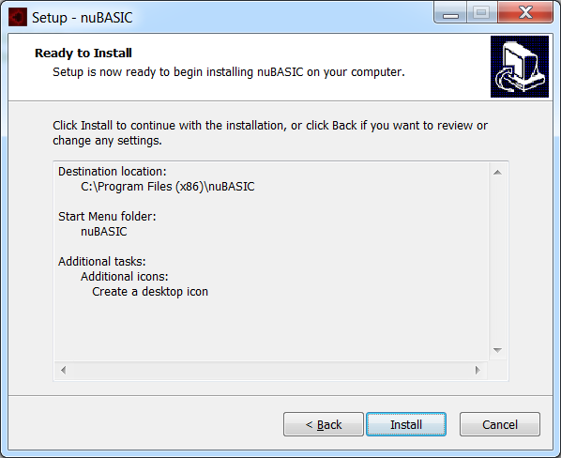

How to install nuBASIC in Linux

Installation Prerequisites
For nuBASIC (full version) to install successfully, the following software components are required on the installation computer:
- X11 - X Windowing System (including xterm, xmessage)

- Simple DirectMedia Layer (SDL) 2-https://www.libsdl.org/
This library is needed from version 1.12 to version 1.16 of nuBASIC (next releases don't need it)
It provides sound facility for implementing PlaySound function.
To install SDL2 on Debian/Ubuntu use the following command:
$ sudo apt-get install libsdl2-2.0-0
To install SDL2 on Fedora/Centos use the following command:
$ yum install SDL2-devel

nuBASIC 1.17 or higher version does not need SDL2.
You may compile nuBASIC either enabling or disabling SDL2 support (--enable-sdl2 configuration switch is provided)
In case of disabling SDL2 support, you need "aplay" external tool in order to exec PlaySound function.
"aplay" is generally part of most basic Linux distributions.

Installer packages
Installer packages (.deb/.rpm), standalone binary installers for several 32/64-bit Linux distributions including Debian, Ubuntu, Fedora, openSUSE, are provided.
You may download the packages following the link https://sourceforge.net/projects/nubasic/files/binary/
To install nuBASIC, double-click on the installer package contained in the related file, and follow the instructions.

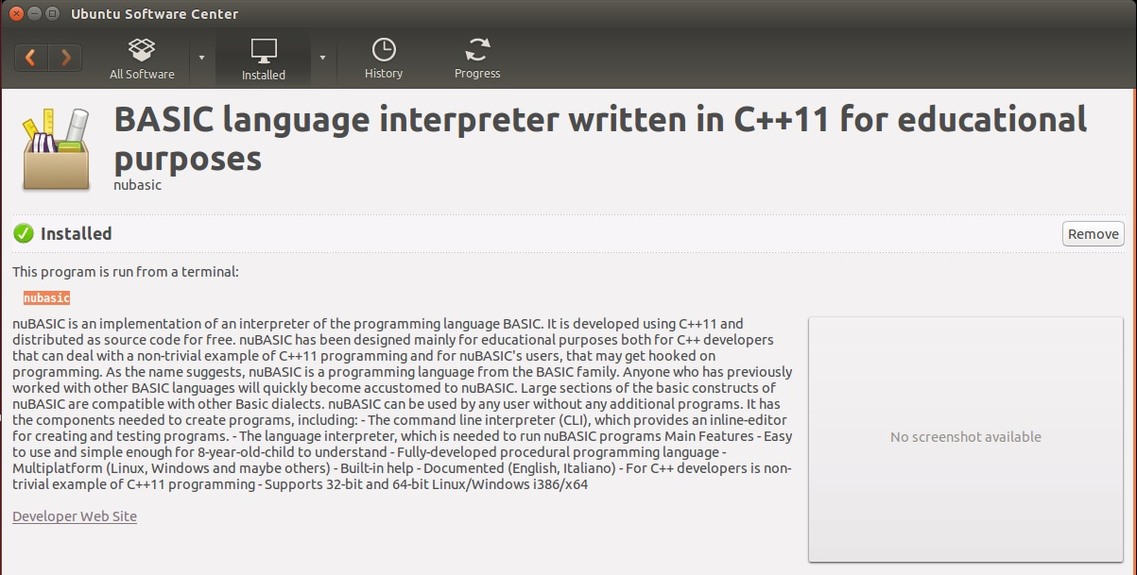

Setup nuBASIC on Debian/Ubuntu
nuBASIC needs xterm for graphical applications. To install xterm on Debian/Ubuntu type the following commands:

sudo apt-get install xterm

Set up xterm in reverse-mode (background black)

Setup nuBASIC on Fedora/Centos
nuBASIC needs xterm for graphical applications. To install xterm on CentOS/Fedora type the following commands:

yum install xterm

Set up xterm in reverse-mode (background black)

Building nuBASIC
You may also install nuBASIC using source packages.
You may download the packages following the link https://sourceforge.net/projects/nubasic/files/source%20code/

Using source package nubasic-<ver>.tar.gz you may install nuBASIC in any Linux distribution:
- Download and uncompress it.
- Enter the package-name directory where you uncompressed it, and just type the following commands:

./configure
make
make install

To build nuBASIC you need g++ compiler and x11 development libraries.
Ubuntu:
- https://help.ubuntu.com/community/InstallingCompilers
Others:
- http://www.rpmfind.net/linux/rpm2html/search.php?query=gcc-c%2b
- %2bhttp://rpmfind.net/linux/RPM/Development_Libraries_X11.html

How to build and install nubasic on CentOS 6.x
Install pre-requirements to build GNU gcc 4.8.2 on CentOS 6.x
yum install gmp-devel mpfr-devel libmpc-devel
Download and extract gcc 4.8.2 source tar ball:
curl -O ftp://ftp.gnu.org/gnu/gcc/gcc-4.8.2/gcc-4.8.2.tar.gz; tar zxf gcc-4.8.2.tar.gz
cd gcc-4.8.2; ./configure --enable-languages=c,c++ --disable-multilib
Build and install:
make; make install

nuBASIC samples
Several examples are distributed with nuBASIC package, these include
(see also https://sourceforge.net/projects/nubasic/files/examples/):

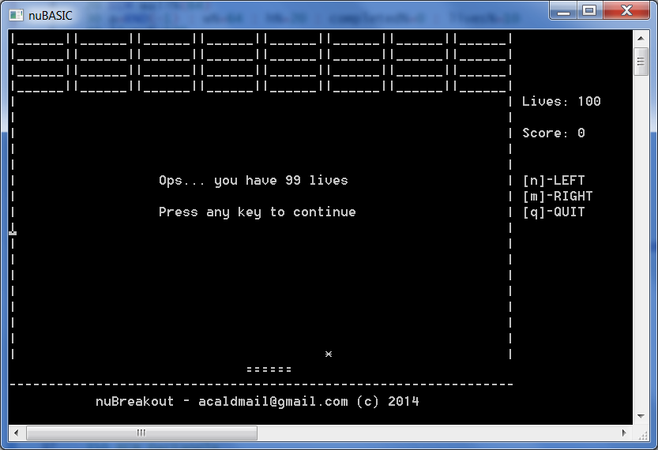 | Breakout.bas  This is text-mode Breakout-clone written in old-fashion BASIC style (using line numbers, GOTO statements and like).  It demonstrates use of standard BASIC's commands.
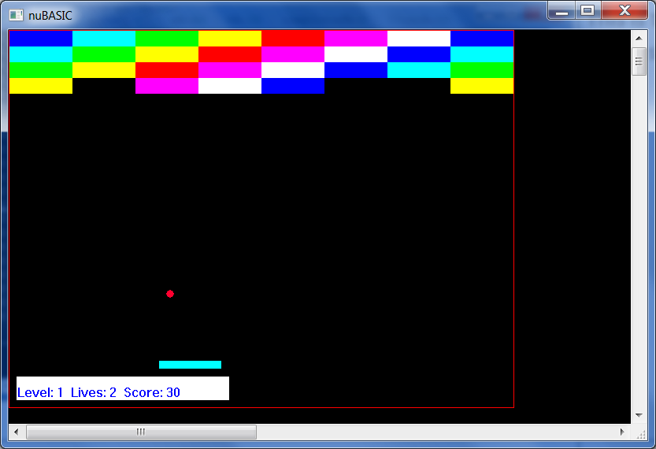 | Breakout2.bas  This is a Breakout-clone written in using GOSUB-style sub-routines and labels.  It demonstrates use of standard old-fashion sub-routines  Breakout3.bas  This Breakout-clone is pretty similar to Breakout2, but it is written by using fully procedural programming style.
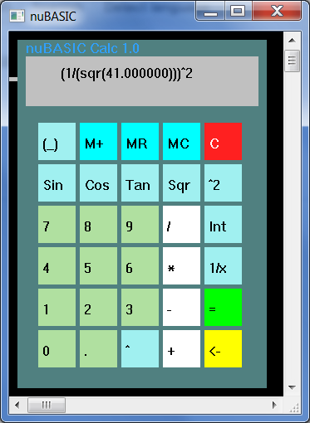 | Calc.bas  This is a simple example of a calculator that uses nuBASIC Eval function, which is able to evaluate complex arithmetic expressions (both integer and floating-point).  The using interface is provided via mouse events, which is required to use the GUI.

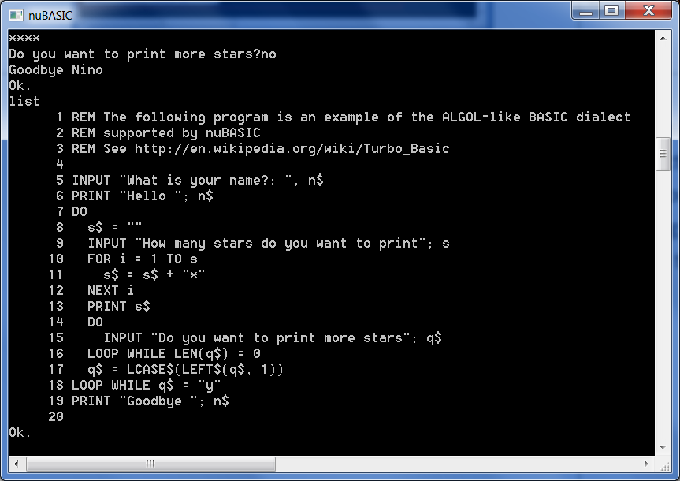 | Code.bas  The following program is an example of the ALGOL-like BASIC dialect supported by nuBASIC.  (See also http://en.wikipedia.org/wiki/Turbo_Basic)
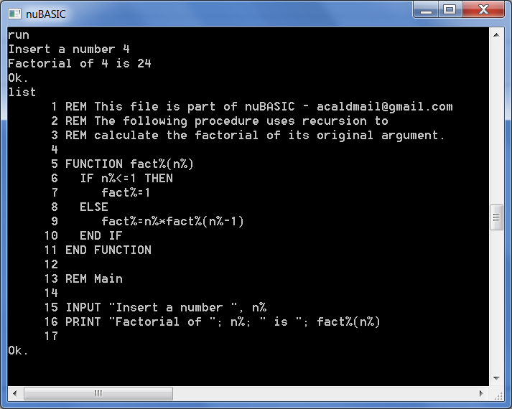 | Fact.bas  Recursive.bas  Examples which use recursion.  Fact.bas shows how to calculate the factorial of an integer number.
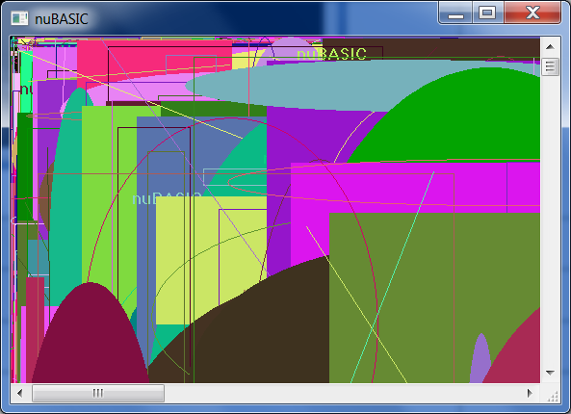 | Graph.bas  This program provides a simple example of graphics programming in nuBASIC
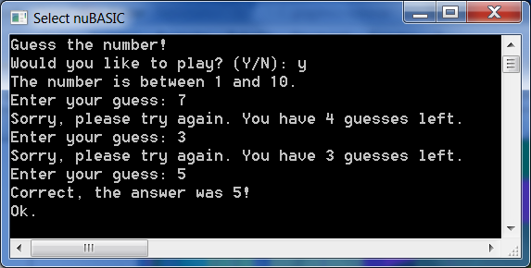 | Guess.bas  This simple game challenges the user to guess a randomly selected number within the 1-10 range, without offering the usual hints of "higher"/"lower".  It is written using QBasic-like dialect syntax supported by nuBASIC.  See also http://en.wikipedia.org/wiki/QBasic

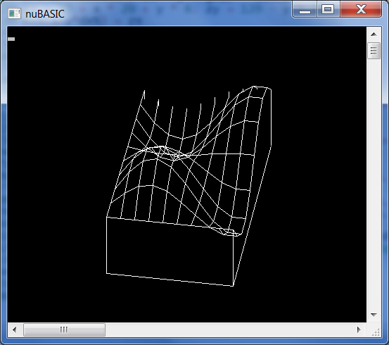 | Line.bas  This example shows how to use array in nuBASIC.
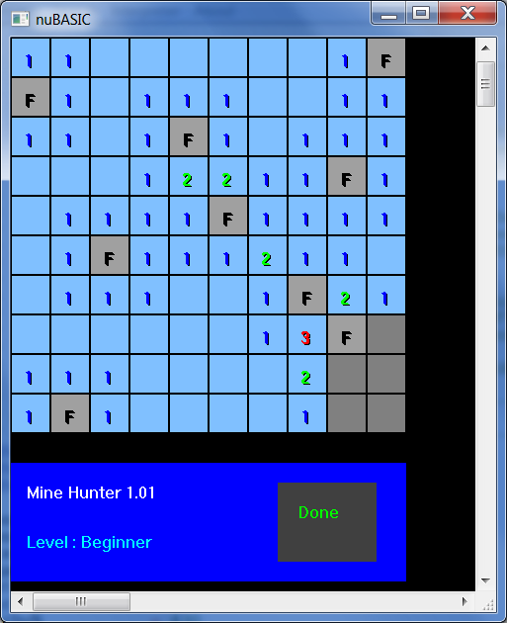 | Minehunter.bas  This is a clone of famous game minesweeper from Windows.  Left-click a field to uncover it; you will see a number corresponding to the amount of neighboring mines.  Right-click a field to flag it if you suspect a mine below it.  Click on “Done” when you complete your job.
nuTetris.bas
This is a Tetris clone written for nuBASIC.
If you don't know Tetris please see the following link
http://en.wikipedia.org/wiki/Tetris

nuTetris3D.bas
This is a variant of nuTris with a virtual “3D-Camera” on board of each falling piece. This shows a 3D projection of scene from that perspective...

Parabola.bas
A simple program which shows how to draw a math curve
http://en.wikipedia.org/wiki/Parabola

Ray.bas
This is an interactive demo which implements a simple Raycasting 3D engine for nuBASIC.
See also http://en.wikipedia.org/wiki/Ray_casting
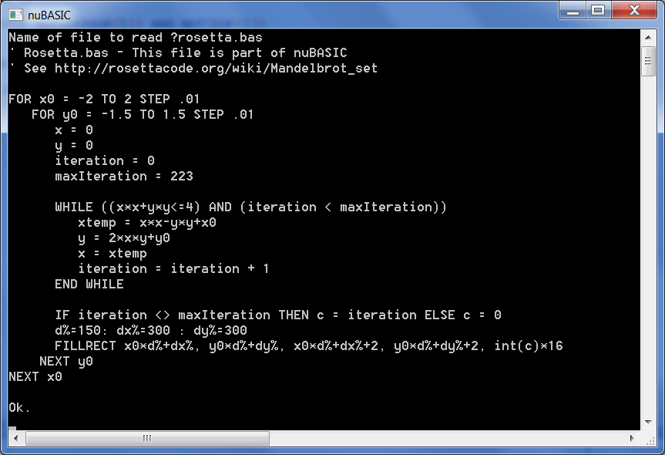 | Readfile.bas  This simple example shows how to read a text file and display its content on the screen.
Rosetta.bas
This example generates and draws the Mandelbrot set.
See also http://rosettacode.org/wiki/Mandelbrot_set

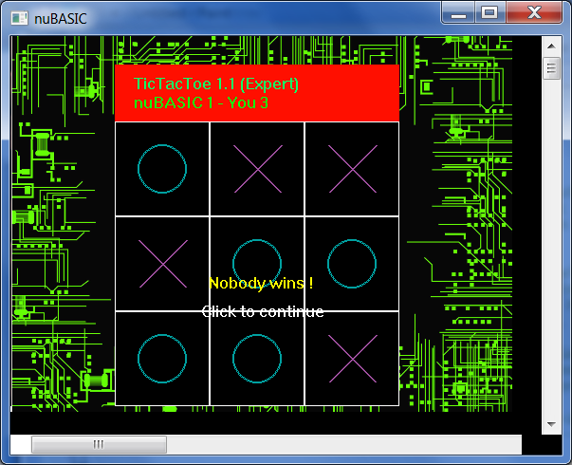 | TicTacToe.bas  This is a paper-and-pencil game for two players, X and O, who take turns marking the spaces in a 3×3 grid. The player who succeeds in placing three respective marks in a horizontal, vertical, or diagonal row wins the game.  See also http://en.wikipedia.org/wiki/Tic-tac-toe

 | Cartoon.bas, Bitmap.bas  These examples shows how to draw bitmap read from file on the screen.  Cartoon shows how to make a simple animation.  Plane shows how to move sprites and background images.
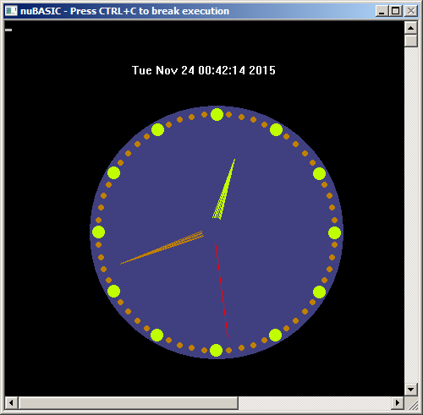 | Clock.bas  Simple clock implementation.

Licenses

NuBASIC interpreter since version 1.48 is distributed as both binary (for Windows and Linux) and source code under MIT License and GPLv2 till version 1.47 (see also the following link https://github.com/eantcal/nubasic/blob/master/COPYING)

IDE distributed as binary and source code for Windows and Linux (GTK+2).
It relies on Scintilla (http://www.scintilla.org/) which is a free source code editing component. It comes with complete source code and a license (http://www.scintilla.org/license.txt) that permits use in any free project or commercial product.

License for Scintilla and SciTE

Copyright 1998-2002 by Neil Hodgson <neilh@scintilla.org>

All Rights Reserved

Permission to use, copy, modify, and distribute this software and its
documentation for any purpose and without fee is hereby granted,
provided that the above copyright notice appear in all copies and that
both that copyright notice and this permission notice appear in
supporting documentation.

NEIL HODGSON DISCLAIMS ALL WARRANTIES WITH REGARD TO THIS
SOFTWARE, INCLUDING ALL IMPLIED WARRANTIES OF MERCHANTABILITY
AND FITNESS, IN NO EVENT SHALL NEIL HODGSON BE LIABLE FOR ANY
SPECIAL, INDIRECT OR CONSEQUENTIAL DAMAGES OR ANY DAMAGES
WHATSOEVER RESULTING FROM LOSS OF USE, DATA OR PROFITS,
WHETHER IN AN ACTION OF CONTRACT, NEGLIGENCE OR OTHER
TORTIOUS ACTION, ARISING OUT OF OR IN CONNECTION WITH THE USE
OR PERFORMANCE OF THIS SOFTWARE.

